Formative Assessment  
How can it improve teaching and learning?

### Handouts

### Contents

* Handout 1: Journey to the Bus Stop 2
* Handout 2: Giving Formative Feedback 3
* Handout 3: Counting Trees Task 5
* Handout 4: Distance-Time Graphs Collaborative Activity 6
* Handout 5: Reflections 10

### Copying

*Except where noted/credited otherwise, these materials are Copyright © 2015-2017 Mathematics Assessment Resource Service, University of Nottingham. They are published under the* [*Creative Commons Attribution-NonCommercial-ShareAlike 4.0 International*](https://creativecommons.org/licenses/by-nc-sa/4.0/) *license, so they may be copied and adapted for non-commercial use under certain conditions and with appropriate attribution. Please see the license for details, or contact us via* [*http://mathnic.mathshell.org/contact.html*](http://mathnic.mathshell.org/contact.html) *if in doubt.*

*All MathNIC materials can be freely downloaded from our website* [*http://mathnic.mathshell.org/*](http://mathnic.mathshell.org/)

## Handout 1: Journey to the Bus Stop

Every morning Tom walks along a straight road from his home to a bus stop, a distance of 160 yards.  
The graph shows his journey on one particular day.

Distance from home in yards

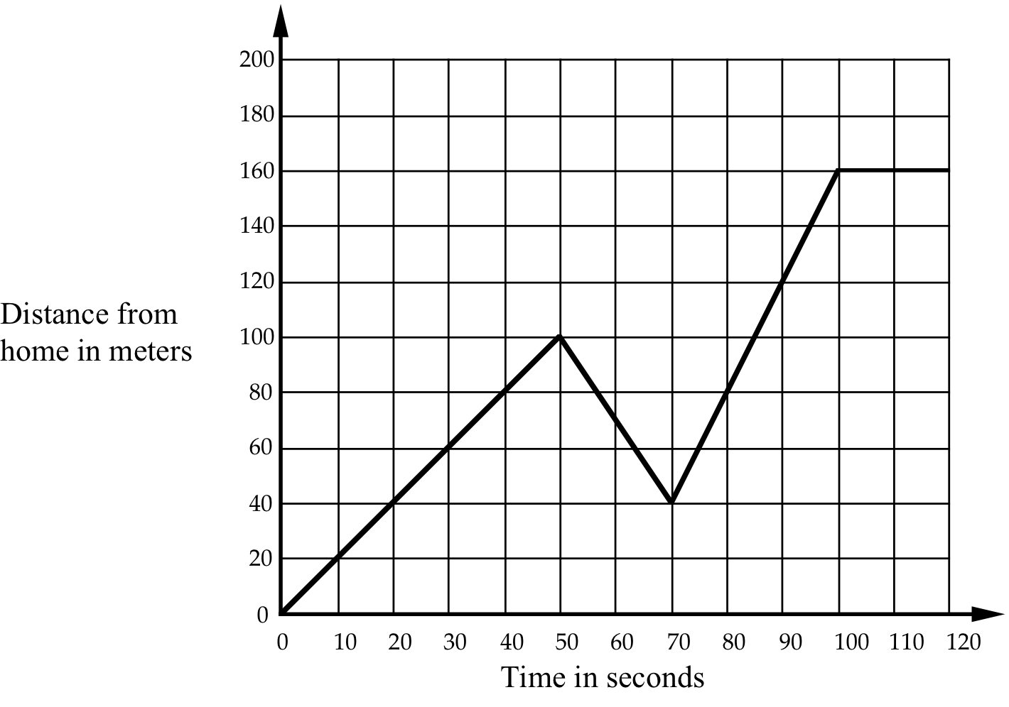

Time in seconds

1. Describe what may have happened.  
You should include details like how fast he walked.

|  |
| --- |
|  |

2. Are all sections of the graph realistic? Fully explain your answer.

|  |
| --- |
|  |

## Handout 2: Giving Formative Feedback

### Journey to the Bus Stop

#### Sample response: Alice

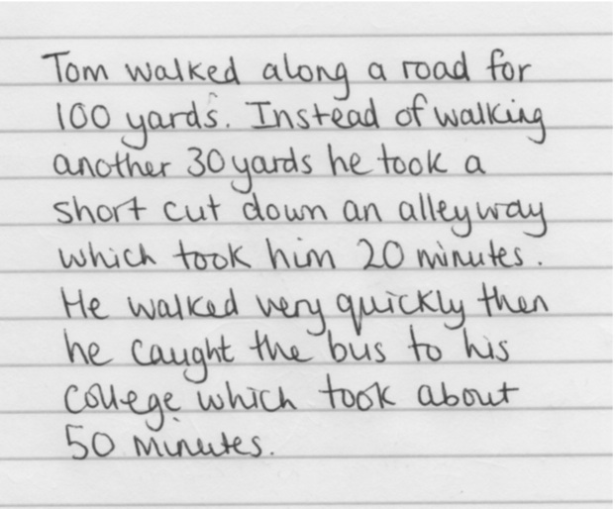

What does Alice’s response tell you about her capacity to tackle the task?

|  |
| --- |
|  |

If you were Alice’s teacher, what formative feedback would you give her to help her improve her understanding or methods?

|  |
| --- |
|  |

### Journey to the Bus Stop

***Sample response: Ben***

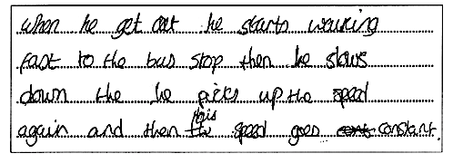

What does Ben’s response tell you about his capacity to tackle the task?

|  |
| --- |
|  |

If you were Ben’s teacher, what formative feedback would you give him to help him improve his understanding or methods?

|  |
| --- |
|  |

## Handout 3: Counting Trees Task



This diagram shows some trees in a tree farm.

The circles show old trees and the triangles show young trees.



Tom wants to know how many trees there are of each type, but says it would take too long counting them all, one-by-one.

1. What method could he use to estimate the number of trees of each type?  
   Explain your method fully.
2. Use your method to estimate the number of:
   1. Old trees
   2. Young trees

## Handout 4: Distance-Time Graphs Collaborative Activity

### Card Set A: Distance­–Time Graphs



### Card Set A: Distance­–Time Graphs (continued)



### Card Set B: Interpretations

|  |  |  |  |
| --- | --- | --- | --- |
| 1 | Tom ran from his home to the bus stop and waited. He realized that he had missed the bus so he walked home. | 2 | Opposite Tom’s home is a hill. Tom climbed slowly up the hill, walked across the top, and then ran quickly down the other side. |
| 3 | Tom skateboarded from his house, gradually building up speed. He slowed down to avoid some rough ground, but then speeded up again. | 4 | Tom walked slowly along the road, stopped to look at his watch, realized he was late, and then started running. |
| 5 | Tom left his home for a run, but he was unfit and gradually came to a stop! | 6 | Tom walked to the store at the end of his street, bought a newspaper, and then ran all the way back. |
| 7 | Tom went out for a walk with some friends. He suddenly realized he had left his wallet behind. He ran home to get it and then had to run to catch up with the others. | 8 | This graph is just plain wrong. How can Tom be in two places at once? |
| 9 | After the party, Tom walked slowly all the way home. | 10 | Make up your own story! |

### Card Set C: Tables of Data

|  |  |  |  |  |  |  |  |  |  |  |  |  |  |  |  |  |  |  |  |  |  |  |  |  |  |  |  |  |  |  |  |  |  |  |  |  |  |  |  |  |  |  |  |  |  |  |  |
| --- | --- | --- | --- | --- | --- | --- | --- | --- | --- | --- | --- | --- | --- | --- | --- | --- | --- | --- | --- | --- | --- | --- | --- | --- | --- | --- | --- | --- | --- | --- | --- | --- | --- | --- | --- | --- | --- | --- | --- | --- | --- | --- | --- | --- | --- | --- | --- |
| P | |  |  | | --- | --- | | Time | Distance | | 0 | 0 | | 1 | 40 | | 2 | 40 | | 3 | 40 | | 4 | 20 | | 5 | 0 | | Q | |  |  | | --- | --- | | Time | Distance | | 0 | 0 | | 1 | 10 | | 2 | 20 | | 3 | 40 | | 4 | 60 | | 5 | 120 | | R | |  |  | | --- | --- | | Time | Distance | | 0 | 0 | | 1 | 18 | | 2 | 36 | | 3 | 54 | | 3 | 84 | | 5 | 120 | |
| S | |  |  | | --- | --- | | Time | Distance | | 0 | 0 | | 1 | 40 | | 2 | 80 | | 3 | 60 | | 4 | 40 | | 5 | 80 | | T | |  |  | | --- | --- | | Time | Distance | | 0 | 0 | | 1 | 20 | | 2 | 40 | | 3 | 40 | | 4 | 40 | | 5 | 0 | | U | |  |  | | --- | --- | | Time | Distance | | 0 | 0 | | 1 | 30 | | 2 | 60 | | 3 | 0 | | 4 | 60 | | 5 | 120 | |
| V | |  |  | | --- | --- | | Time | Distance | | 0 | 0 | | 1 | 20 | | 2 | 40 | | 3 | 40 | | 4 | 80 | | 5 | 120 | | W | |  |  | | --- | --- | | Time | Distance | | 0 | 0 | | 1 | 45 | | 2 | 80 | | 3 | 105 | | 4 | 120 | | 5 | 125 | | X | |  |  | | --- | --- | | Time | Distance | | 0 | 120 | | 1 | 96 | | 2 | 72 | | 3 | 48 | | 4 | 24 | | 5 | 0 | |
| Y | |  |  | | --- | --- | | Make this one up! | | | Time | Distance | | 0 |  | | 1 |  | | 2 |  | | 3 |  | | 4 |  | | 5 |  | | 6 |  | | 7 |  | | 8 |  | | 9 |  | | 10 |  | | Z | |  |  |  | | --- | --- | --- | | Make this one up! | | | | Time | Distance | | 0 |  | | 1 |  | | 2 |  | | 3 |  | | 4 |  | | 5 |  | | 6 |  | | 7 |  | | 8 |  | | 9 |  | | 10 |  | |  |  |

## Handout 5: Reflections

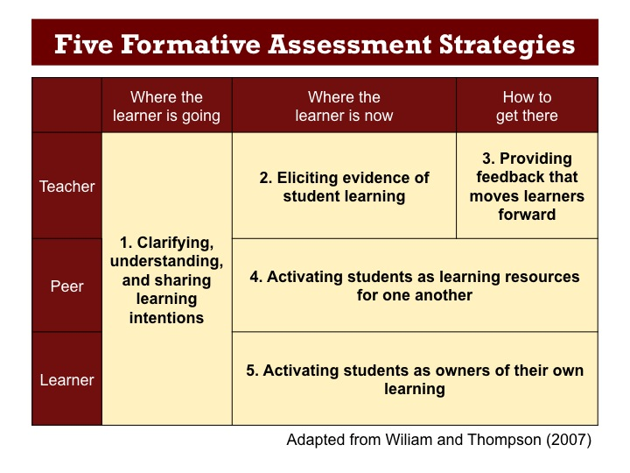

|  |  |
| --- | --- |
| **Initial individual task** | Strategy no. |
| a. Students tackle the ‘Journey to the Bus Stop’ problem |  |
| b. Teacher assesses work and prepares formative feedback |  |
|  | |
| **Whole class introduction** | |
| c. Students choose which of three stories matches a given graph |  |
|  | |
| **Collaborative work** | |
| d. Students work together on a card sort, matching written descriptions with graphs |  |
| e. Tables of data are added to the card sort |  |
|  | |
| **Small group discussions** | |
| f. Students compare their matched cards with another group |  |
|  | |
| **Whole class discussion** | |
| g. Student work is discussed as a whole class, drawing out the significant learning points |  |
|  | |
| **Individual reflection** | |
| h. Students reflect on their work and try to improve their individual work on a post task |  |

### Formative Assessment in the Classroom

What methods of formative assessment are you planning to implement in the coming weeks? List them under the appropriate strategy in the table below:

|  |  |  |  |  |
| --- | --- | --- | --- | --- |
| **1. Clarifying, understanding, and sharing learning intentions** | **2. Eliciting evidence of student learning** | **3. Providing feedback that moves learners forward** | **4. Activating students as learning resources for one another** | **5. Activating students as owners of their own learning** |
|  |  |  |  |  |
|  | | | | |

How do you plan to implement these methods with your students?

|  |
| --- |
|  |