Mathematical Practices
Helping students to develop the practices in their math lessons
Leader Guide
goals
This tool provides teachers with a framework for monitoring and helping students to develop the Mathematical Practices in the classroom.
Users
Professional development leaders with a group of mathematics teachers.
Introduction
The Common Core State Standards for Mathematical Practice describe varieties of expertise that mathematics educators at all levels should seek to develop in their students. These practices rest on important ‘processes and proficiencies’ with long-recognized importance in mathematics education (Common Core State Standards Initiative). The Practices have been included in most revised State Standards.
This session provides a framework for assessing students’ proficiency in planning, presenting, analyzing and reflecting as they learn mathematics. By considering examples of characteristics that exemplify a student’s proficiency in any given practice, it is hoped that teachers will be stimulated to actively monitor, as well as encourage their students to self assess their proficiency at the Mathematical Practices in an endeavor to improve.

Session Outline
- The Common Core State Standards for Mathematical Practice 15 minutes
- Processes in the Mathematical Practices 15 minutes
- Looking at Tasks 20 minutes
- Engagement Strategies 10 minutes
- Empowerment Strategies 10 minutes
- Supporting Students in the Classroom 20 minutes
Materials required
- This Leader’s Guide, supported by a PowerPoint: ‘Mathematical Practices Slides.pptx’
- Session Handouts: One copy per person.
Time needed
90 minutes

Preparation
The workshop leader(s) should carefully work through this Guide, referring to the Handouts. For the core Activity Sequence (below) it covers the same material as on the PowerPoint slides, including the notes below each slide.
Fill in your local information on the first and last slides.
Try to anticipate the common issues that participants will have and note down your responses to them, below. The ones shown below are examples taken from trials of this session.
Common concern | Suggested responses
I don’t need to think about the mathematical practices as they just happen in the classroom | - Can you give an example of some characteristic behaviors that would demonstrate that a student is operating in one of the practices?  - In what ways are your students aware that they are demonstrating the mathematical practices in the classroom?
The curriculum we use doesn't seem to need the mathematical practices | - That can be a problem, particularly with a traditional curriculum that just focuses on procedural skills.  Adding more substantial problems that require longer chains of reasoning will benefit your students in many ways: bringing in the mathematical practices and developing more robust understanding of concepts and skills.  (The lessons at map.mathshell.org are one good source for Grades 6 through 10/11.)

Activity Sequence
Title Slide  You may like to customize this slide and/or the last one with your own institutional and contact details. Please leave the copyright attribution, however.  Possible comments below are in plain text. Suggestions are in italics.  Users will, of course, adapt as necessary – though we recommend sticking with this activity sequence the first time or two.  Today’s workshop is about exploring the mathematical practices and identifying ways in which, as teachers, we can both promote and monitor students’ development of the practices in our classrooms. | Slide 1  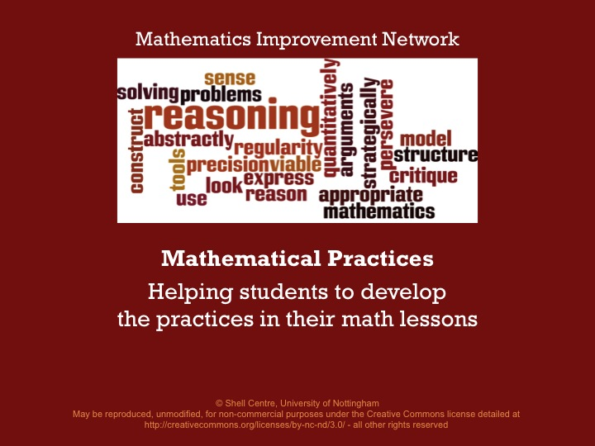
Workshop Outline  Here is an outline of what we are going to work through today, as we look at the ways in which students develop the Mathematical Practices:  Rough timing  Standards for Mathematical Practice (15 mins)  Processes in the Practices (15 mins)  Looking at Tasks (20 mins)  Engagement Strategies (10 mins)  Empowerment Strategies (10 mins)  Supporting Students in the Classroom (20 mins) | Slide 2  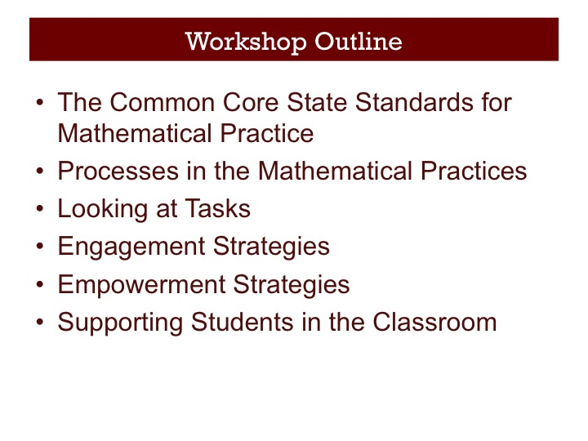
The Common Core State Standards for Mathematical Practice (15 minutes)  We are all familiar with the Common Core State Standards for Mathematical Content and Practice. While the Content Standards describe the structure of mathematical knowledge, the Standards for Mathematical Practice describe the ways in which proficient practitioners of mathematics carry out their work.  Let’s have a look at the practices in a bit more detail … | Slide 3  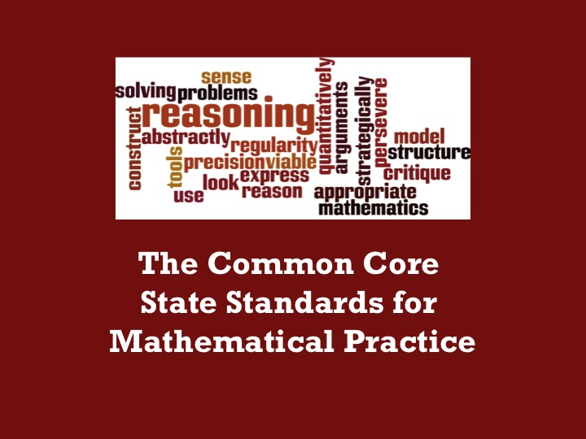
Direct participants to Handout 1.  The full descriptions of the Standards for Mathematical Practice describe ways in which students ought to engage with mathematics as they grow in expertise throughout the elementary, middle, and high school years.  The eight practices describe essential mathematical habits that we want to see extending throughout the curriculum and pedagogy of mathematics. The detailed descriptions give us an insight into the kinds of student behavior we are looking for, so let’s look at each of the practices in detail and draw out some of the key features … | Slide 4  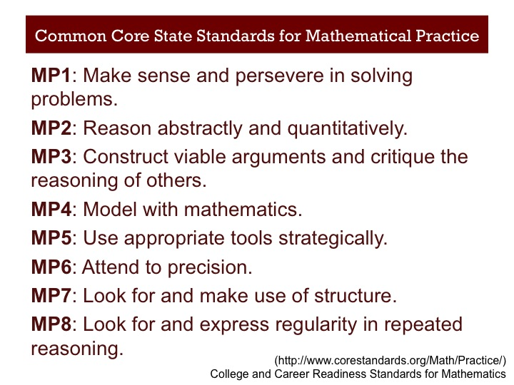
The first practice considers the ways in which students make sense of the problems they are invited to solve.  Students should be able to explain the meaning of a problem and actively look for ways that it can be solved.  Rather than jumping right into an attempt at a solution, students need to  - critically analyze the problem  - consider the form and meaning of the solution, and  - plan a pathway to get there  If that approach doesn't work out, persevere. | Slide 5  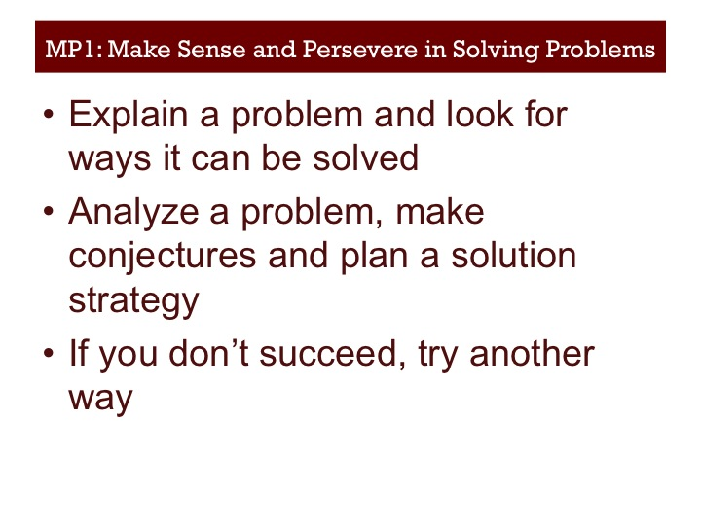
Making sense of quantities and their relationships when problem solving is an important skill for students to possess, as they develop their ability to reason.  This involves creating coherent arguments and using symbols to represent mathematical situations. Students should be able to use the different properties of operations and objects flexibly too. | Slide 6  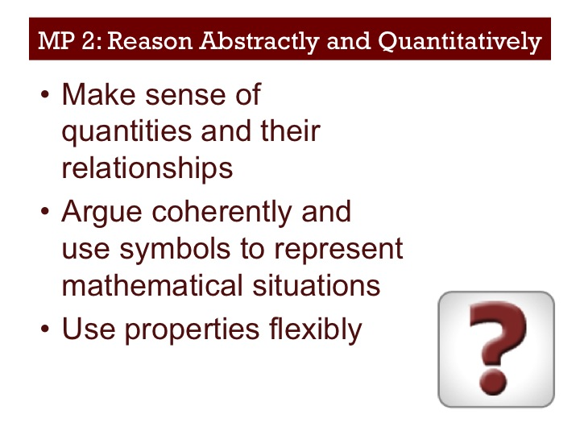
When constructing arguments, students should be able to refer to definitions, theorems, and previously established results.  They need to build a logical progression of claims, using examples to justify their conclusions.  It’s also important that students are able to distinguish correct reasoning from that which is flawed. | Slide 7  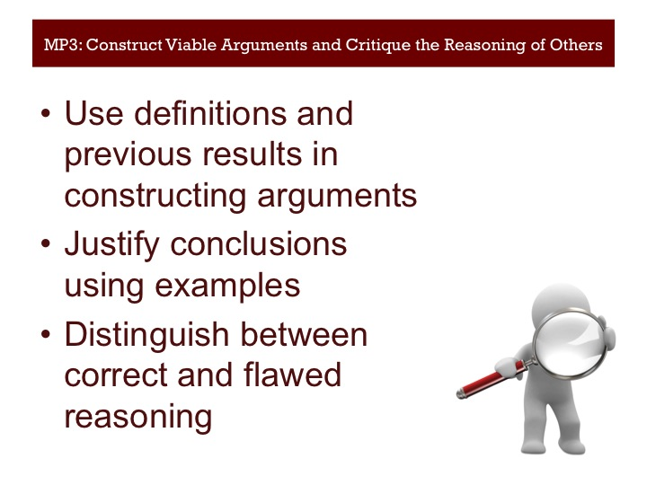
MP4 brings math outside of the classroom, with students taking the skills they’ve learned in class and applying it to situations they encounter in everyday life.  Modeling with mathematics requires students to  - make assumptions and approximations to simplify a situation  - represent the relationships mathematically  - interpret mathematical results in the context of the situation, and  - reflect on whether they make sense | Slide 8  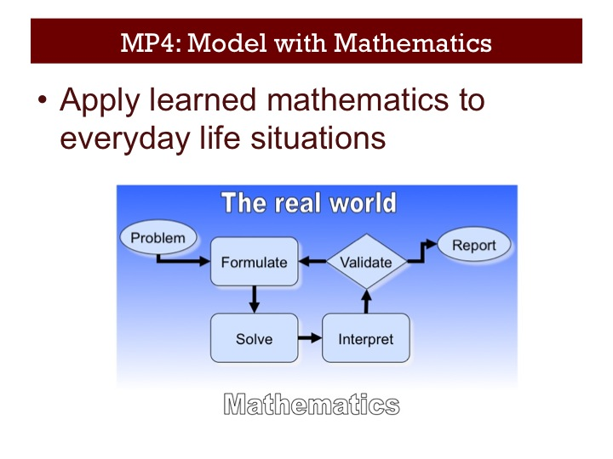
MP5, ‘Use Appropriate Tools Strategically’ addresses the types of tools that support mathematics learning and how to use them.  When solving math problems, students need to consider the tools they have available to them. This can range from pencil and paper, to a calculator or protractor, to math software. They should be able to identify which tools will be most helpful and use them appropriately.  The use of appropriate tools is essential for students to get the most out of a mathematical task. | Slide 9  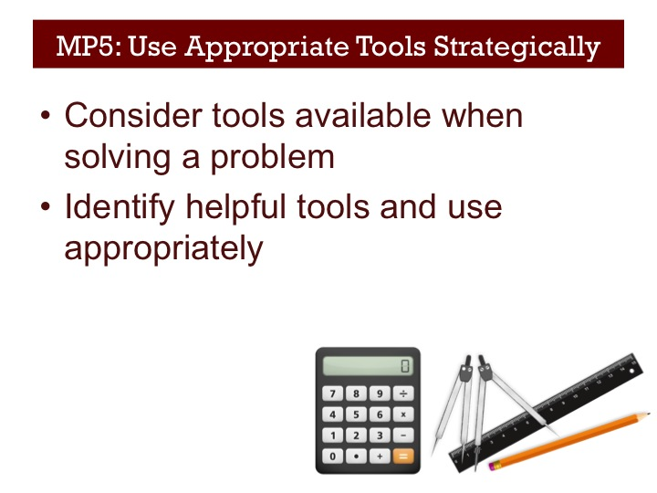
Good mathematical practice involves the ability to communicate what has been learned.  Students must be able to use mathematical definitions to clearly and accurately explain their reasoning.  In addition, they should be precise in their work, for example when using units of measure or labeling axes etc. | Slide 10  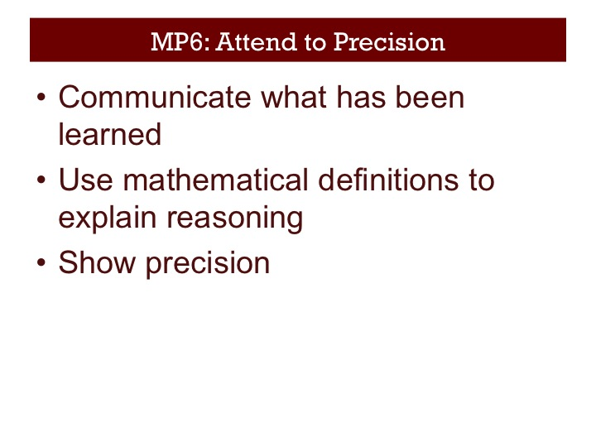
Students should be able to discern patterns and structures in math.  Of course, what this means varies depending upon grade level.  Elementary math students, for example, should know that 4+5 and 5+4 mean the same thing.  High school students will need to note regularity in the way things cancel out when expanding an equation.  You can see how the number of matchsticks grows as the sequence of "houses" on the slide is extended. The challenge is to express it in mathematics - in arithmetic or in algebra.  Try it with your neighbor, using Handout 2.  Give them a few minutes to work on this, monitoring the discussions.  The rule: m = 5h + 1. | Slide 11  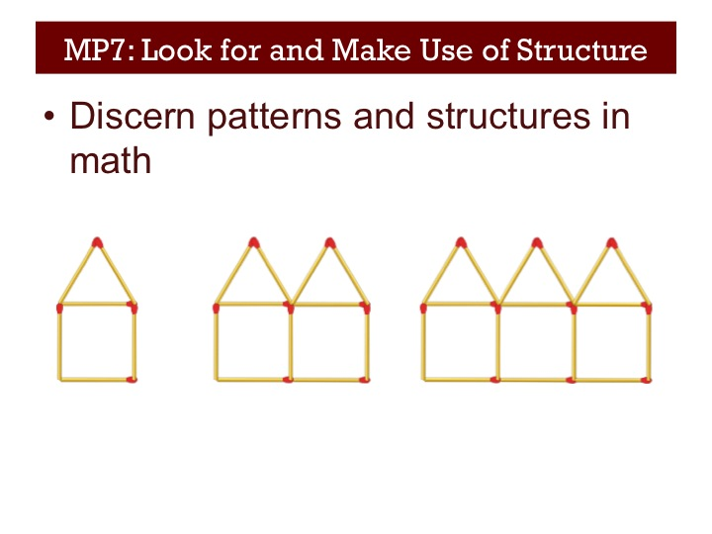
More advanced math students should be able to recognize when calculations are repeated and be constantly looking for shortcuts - patterns that can be represented by a rule or formula, as with the Matchstick Houses problem.  As they work through math problems, students should continually re-evaluate if they are on the right track. | Slide 12  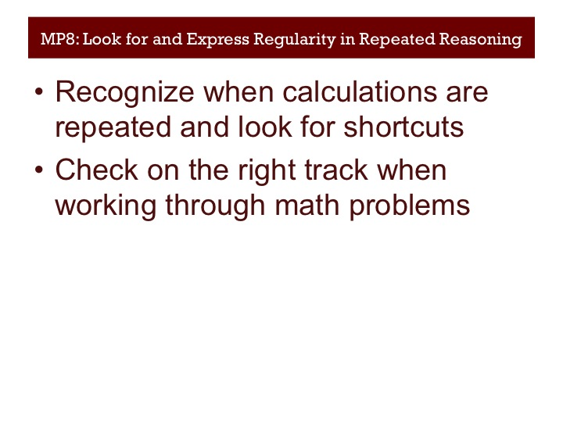
Processes in the Mathematical Practices (15 minutes starting after 15 minutes)  While we have considered the Mathematical Practices as eight separate items, they have many interconnections with each other. Indeed, the authors of the Standards stressed that the Practices should be seen as a whole.  Let’s take a look at the Processes within the Mathematical Practices to help us to see the ways in which the practices interrelate. | Slide 13  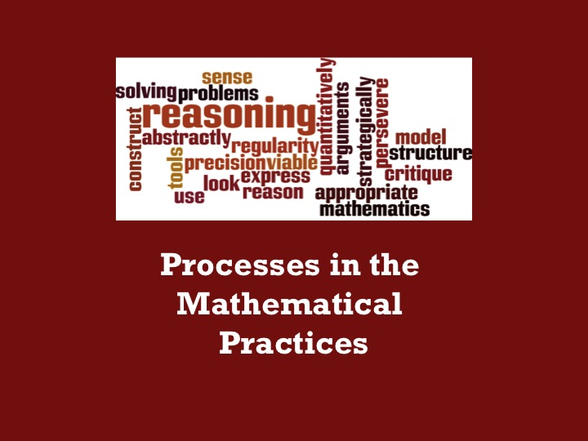
Five Content Standards (describing the strands of content that students should learn) and five Process Standards were defined in the ‘Principles and Standards for School Mathematics’. The Process Standards are:  (1) Problem Solving  (2) Reasoning and Proof  (3) Communication  (4) Connections  (5) Representations  Here we have the relationships among the practices within the process standards. Practices 1 and 6 serve as overarching habits of mind in mathematical thinking and are pertinent to all mathematical problem solving. Practices 2 and 3 focus on reasoning and justifying, both for oneself and for others, and are essential for establishing the validity of mathematical work. Practices 4 and 5 are particularly relevant for preparing students to use mathematics in their work. Practices 7 and 8 involve identifying and generalizing patterns and structure in calculations and mathematical objects. | Slide 14  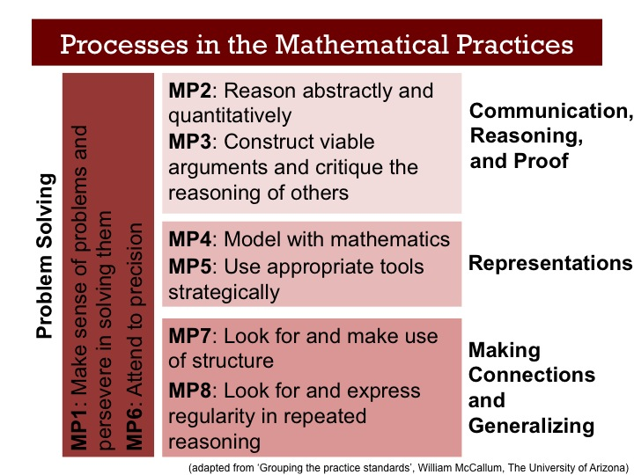
Problem Solving  Let’s now look at each of these overarching processes in turn, starting with Problem Solving … | Slide 15  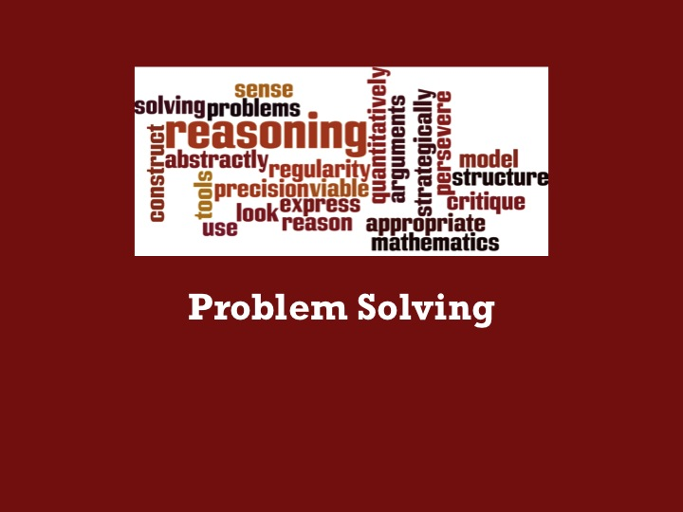
Solving problems is not only a goal of learning mathematics but also a major means of doing so. Students require frequent opportunities to formulate, grapple with, and solve complex problems that involve a significant amount of effort. They are to be encouraged to reflect on their thinking during the problem-solving process so that they can apply and adapt the strategies they develop to other problems and in other contexts.  By solving mathematical problems, students acquire ways of thinking, habits of persistence and curiosity, and confidence in unfamiliar situations that serve them well outside the mathematics classroom. | Slide 16  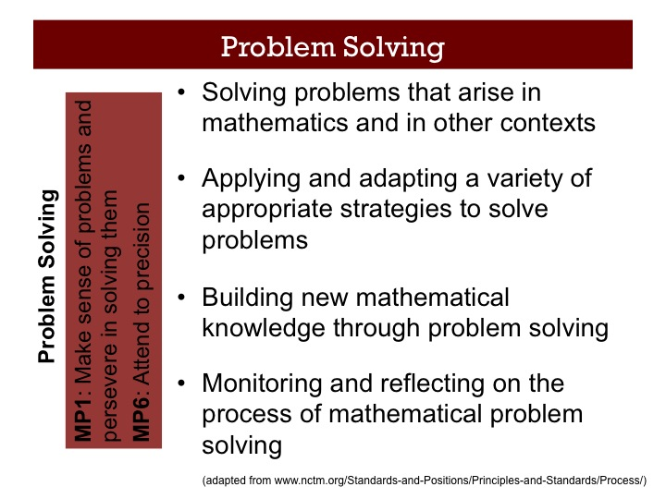
Communication, Reasoning, and Proof  The second and third process standards are demonstrated in the relationship between MP2 and MP3. Let’s now look at the connection between these two practices … | Slide 17  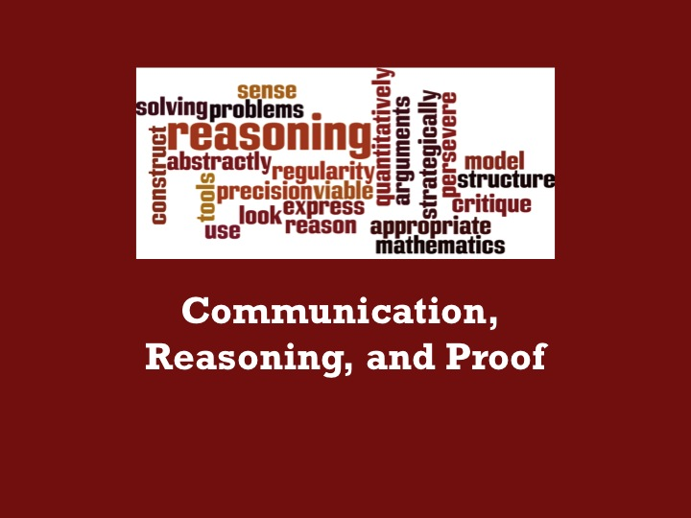
Mathematical communication is a way of sharing ideas and clarifying understanding. When students are challenged to communicate the results of their thinking to others, they learn to be clear, convincing, and precise in their use of mathematical language.  Mathematical reasoning and proof offer powerful ways of developing and expressing insights about a wide range of phenomena. By exploring mathematical conjectures and justifying results, students should begin to see that mathematics makes sense. | Slide 18  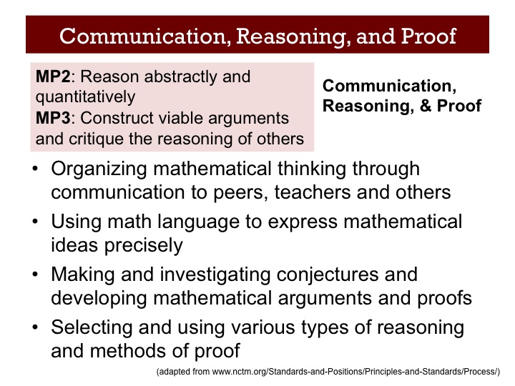
Representations  The fifth process standard provides an overarching description of practices MP4 and MP5. Let’s take a look … | Slide 19  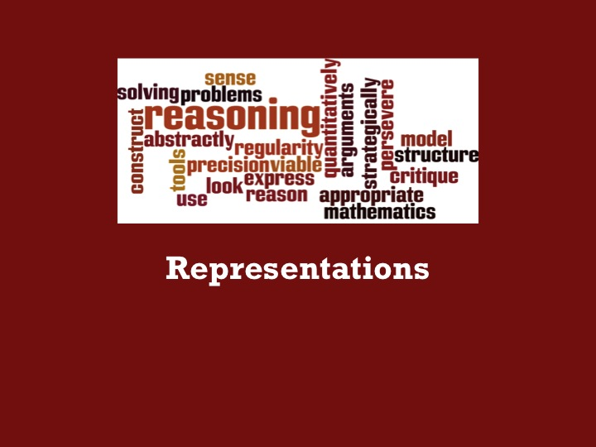
Mathematical ideas can be represented in a variety of ways. The ways in which mathematical ideas are represented is fundamental to how people understand and use those ideas.  The same is true of real world situations, which can be better understood through mathematical models - as we did with Matchstick Houses.  When students gain access to mathematical representations and the ideas they express, and when they can create representations to capture mathematical concepts or relationships, they acquire a set of tools that significantly expand their capacity to model and interpret physical, social, and mathematical phenomena. | Slide 20  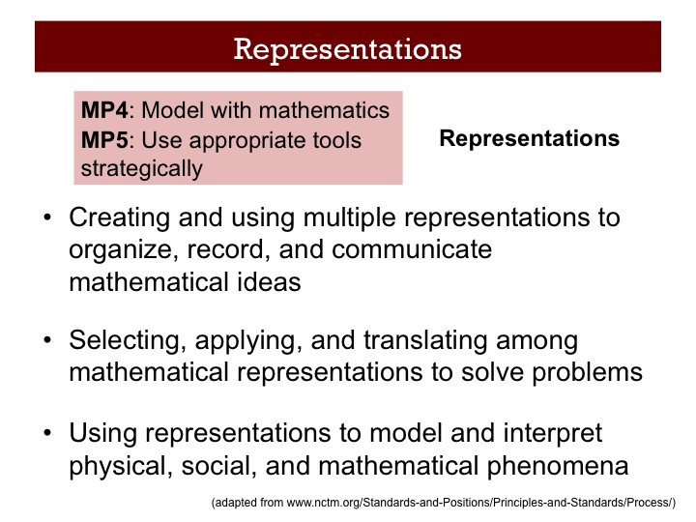
Making Connections and Generalizing  The remaining two Mathematical Practices, MP7 and MP8, fall under the final (fourth) practice standard of ‘Connections’. As students begin to make connections, they are able to generalize both within and outside the context of mathematics.  Let’s look at how these two practices fit within this process standard … | Slide 21  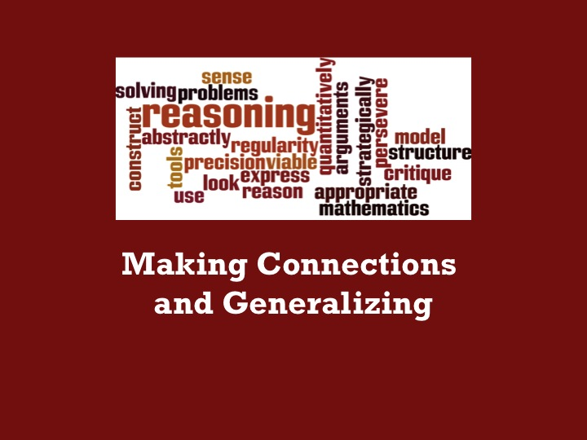
Mathematics is not a collection of separate strands, but an integrated field of study. As students develop these two practices, they begin to see connections between topics, in contexts that relate mathematics to other subjects, and in their own interests and experience.  When students connect mathematical ideas, their understanding is deeper and more lasting, and they come to view mathematics as a coherent whole. | Slide 22  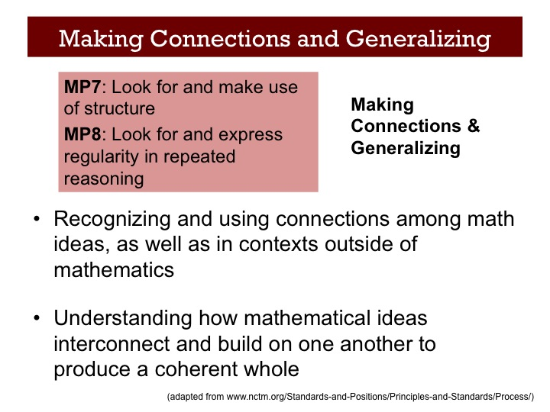
Looking at Tasks  (20 minutes starting after 30 minutes)  By carefully selecting the tasks we give to our students, we can promote their development of the practices. In order to ensure a comprehensive coverage of the eight Mathematical Practices, it is helpful for us to identify the specific practices that a task addresses so let’s have a go at doing that with a task now … | Slide 23  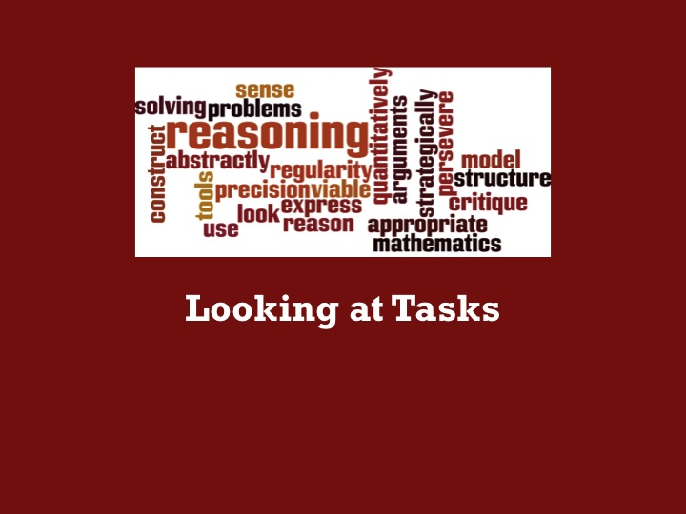
You will find a copy of the Table Tiling task in Handout 3.  The core problem is to work out how many whole, half and quarter tiles are needed to cover the tops of tables of different sizes.  In this "apprentice" version of the task, students are given guidance on how to tackle it. | Slide 24  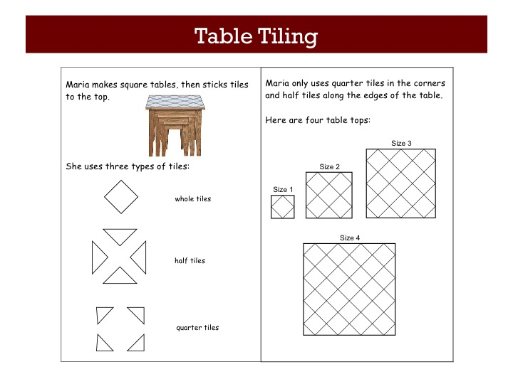
On your own, spend a few minutes working through the task, answering the four questions. As you work, consider the different ways in which your students might approach the task.  Once you are familiar with the task and its solution, discuss with your neighbour which of the eight Mathematical Practices (see Handout 1) you think students would have opportunity to specifically developing as they work on a solution. Use Handout 4 to write down the practice(s), identifying at which point in the solution process the different practices emerge. | Slide 25  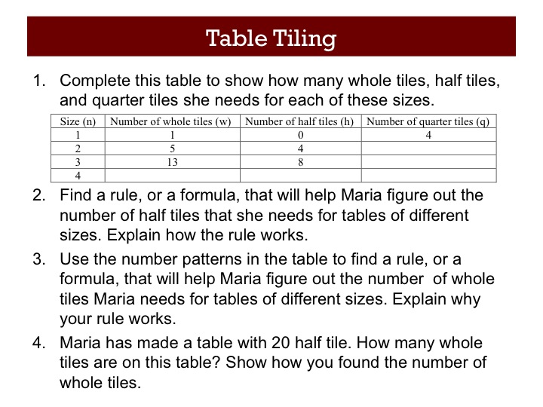
When participants have had sufficient time to agree on the identifiable practices, spend a few minutes discussing ideas as a whole group. While it is not essential for all groups to have identified exactly the same practices, an agreement on the main mathematical practice(s) that students will have the opportunity to develop will hopefully be identified.  (Spending time working through this process yourself, prior to the workshop, will help in leading this discussion).  Let’s see which of the eight mathematical practices we have identified and whether or not we agree!  Choose a group to start the discussion, getting feedback from other groups to see whether or not they are in agreement.  The practices are not intended to be free floating proficiencies, unconnected with content or with each other, nor are they uniformly applied over all the work that students do. Identifying concrete examples of skills that students might demonstrate when completing a particular task, that we can look out for, not only enables us to ensure students have a balanced exposure to the eight practices in the tasks we use in our classrooms, but also provides a means of measuring students’ practice proficiency, which we will look at next. | Slide 26  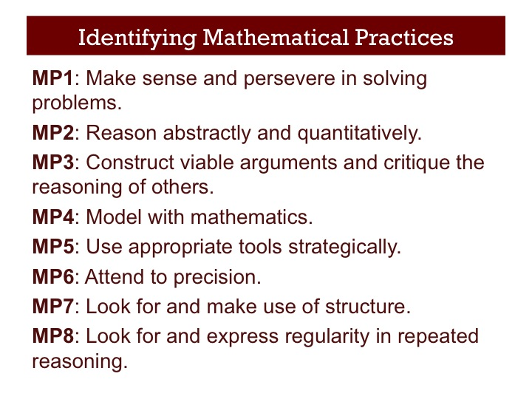
Engagement Strategies  (10 minutes starting after 50 minutes)  There are a number of instructional strategies that teachers can use to support the development of students’ proficiency in the mathematical practices.  These can involve a major shift in pedagogy and belief, moving from engagement strategies, which we will look at first, to empowerment strategies, which we will consider afterwards. | Slide 27  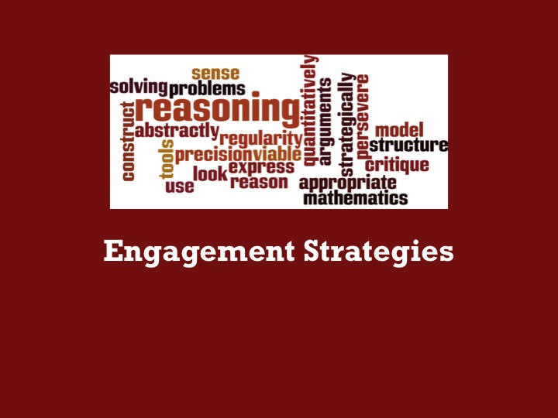
Three strategies that encourage students to think for themselves, reveal the reasoning behind their thinking and increase the levels of thinking for all students in the math classroom are:  (1) Pair-Share  (2) Showing Thinking and  (3) Questioning and Wait Time  We will look at each of these strategies in turn. | Slide 28  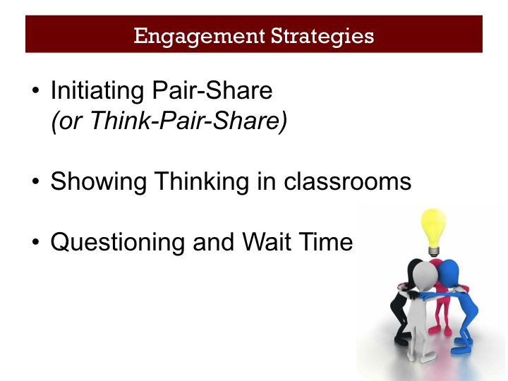
‘Pair-share’ can be easily implemented in any classroom, at any grade level and doesn’t require any change in pedagogy or materials.  When a question or problem is posed, students are given the opportunity to think and work with a partner for a few minutes, before being asked to provide an answer.  In ‘Think-Pair-Share’, students are given time to think independently before working with a partner.  While easy to implement, this strategy is a significant first step in engaging all students in classroom instructional activities. | Slide 29  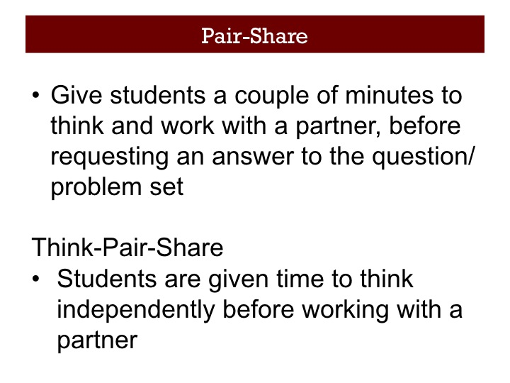
We routinely ask students in our classrooms to share their thinking. However, we can often accept a description of process, with students providing the steps they used to solve the problem, rather than their reasoning and thinking about how they knew which processes to use.  To reveal student thinking, more challenging, open-ended problems are needed.  There is also the need to work toward higher degrees of student involvement in classroom activities. Once pair-share is incorporated into classroom routines, additional strategies that promote ‘every pupil response’ need to also be integrated, including things like ‘thumbs up/thumbs down’ or use of individual white boards for noting answers.  Students should also be encouraged to be more aware of their thinking and express it in detail. | Slide 30  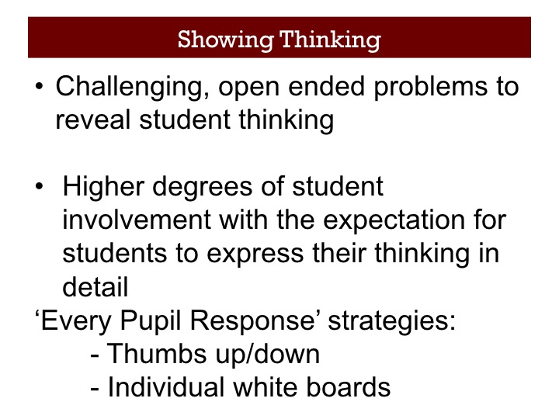
As thinking is increased in the math classroom, better questioning and wait time are required. We need to provide thought provoking questions to students and then allow students plenty of time to think and work towards an answer.  As we engage in these strategies over a period of time, they become familiar and we become comfortable with these classroom behaviors.  As we as teachers reach this comfort zone, student learning increases and we move into the second stage, or empowerment.  We will now look at four empowerment strategies. | Slide 31  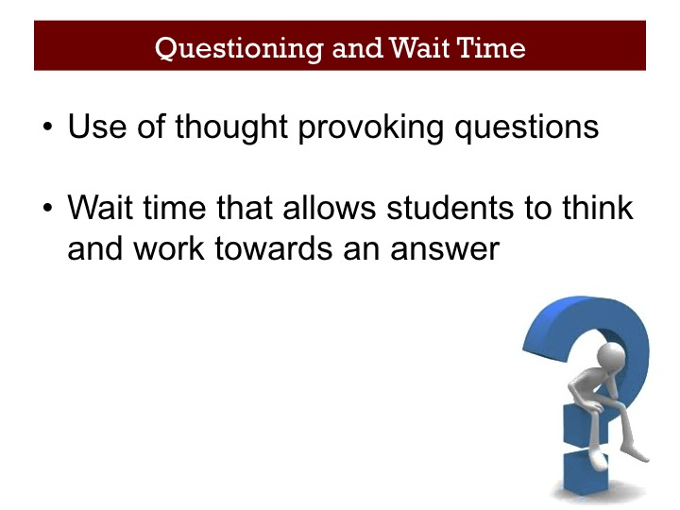
Empowerment Strategies  (10 minutes starting after 60 minutes)  When shifting from engagement to empowerment, teachers begin to use strategies with ease, making adaptations that further increase student learning.  Let’s take a look at some empowerment strategies … | Slide 32  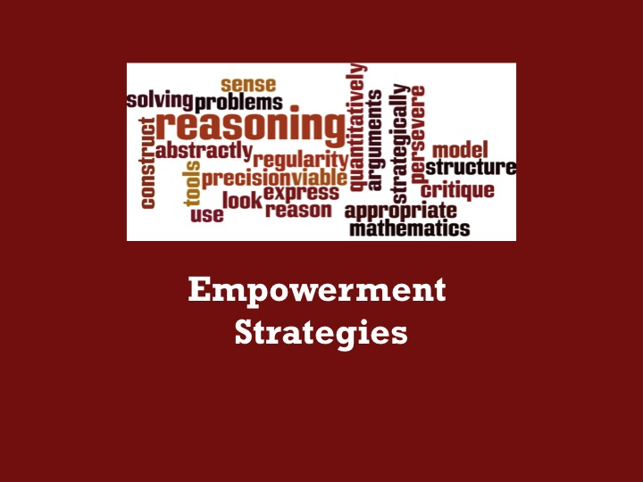
These four empowerment strategies address grouping students, questioning methods, appropriate degrees of difficulty and developing understanding.  We will begin by looking at group work. | Slide 33  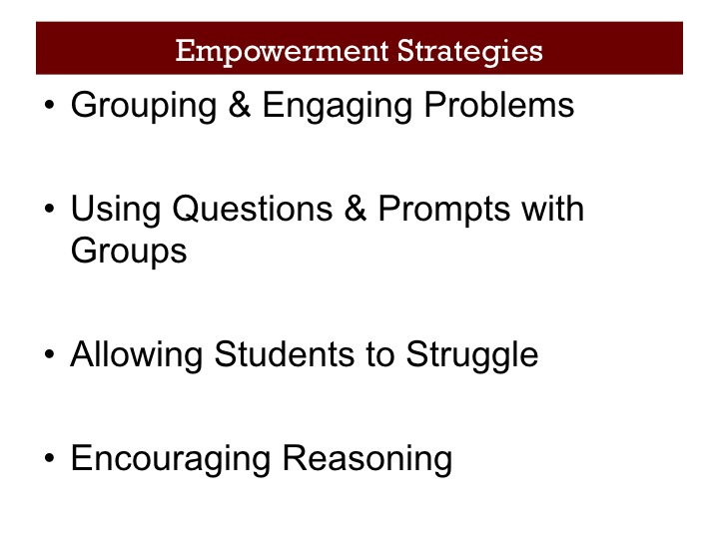
The strategy of grouping students and providing engaging problems may be a significant shift for some teachers. Students are given challenging problems and allowed to work in groups of two, three or four.  Challenging math problems take time, effort, reasoning, and thinking to solve. Teachers need to balance working in groups and working independently and be able to quickly adjust grouping strategies as the need arises. | Slide 34  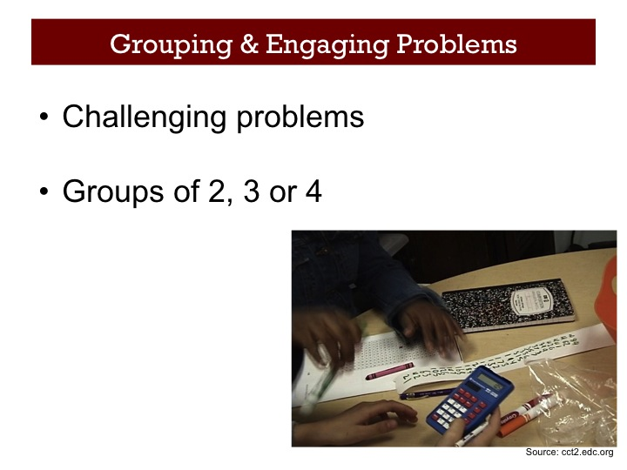
Once students have been given opportunities to solve challenging problems in groups, we need to ask supporting questions that encourage students to continue working.  Providing students with hints or cues without giving them the answer, and asking probing questions, allows us to better assess students’ thinking and understanding. | Slide 35  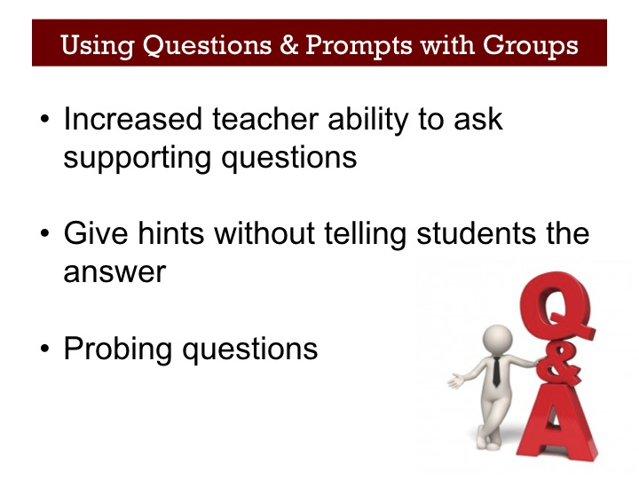
Students learn to persevere in solving mathematics problems by being allowed to struggle. If the problem is too easy, students do not need to struggle. If the problem is far too difficult, students are not capable of solving it and get frustrated.  ‘Productive struggle’ is the goal.  Students need to understand that mathematical problems do not usually have a quick, easy solution. Effective effort is a life-skill and should be learned interdependently and independently. | Slide 36  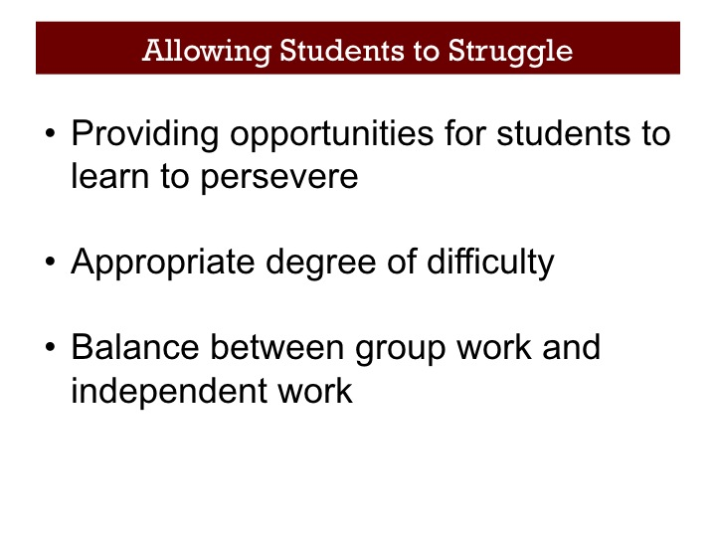
Students need to be encouraged to think carefully about mathematics and to understand their level of knowledge. They also need to be able to accurately communicate their thinking. Reasoning requires students to pull together patterns, connections, and their understandings about the rules of mathematics, and then apply their insight into finding a solution to a difficult, challenging problem.  The pedagogical shift brought about by these four empowerment strategies and the resulting change in classroom culture helps students to develop in their proficiency, increasing awareness for both them and us as teachers, of their current competencies and areas needing development.  Having looked at the strategies, let’s now look at some students working on a problem. | Slide 37  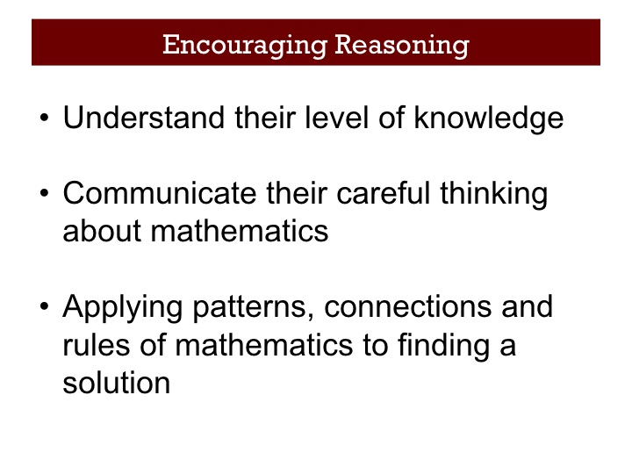
One of the lessons designed as part of the Mathematics Assessment Project (freely available at map.mathshell.org) provides a problem involving sampling as a way of estimating the number of trees on a tree farm.  There are two types of tree on the farm, with circles representing old trees and triangles representing young trees. Students are posed with two questions to solve as part of this problem:  (1) Explain fully a method Tom could use to estimate the number of trees of each type.  (2) Use your method to estimate the number of old and young trees.  I want to show you a 2-minute video of students describing their method for estimating the number of trees of each type. Before we watch the video, spend a few minutes familiarizing yourself with the task and considering possible approaches.  You will find a copy of the task on Handout 5. | Slide 38  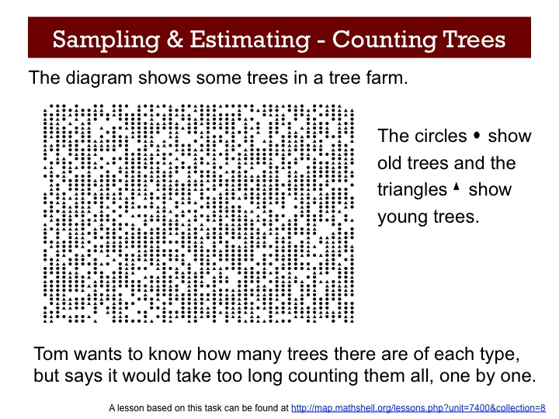
Click on the slide to reveal video control  As Odessa, Noe and Khalil talk about their work, ask the participants to try to identify which of the practices they are using.  The video made by students and teachers at Willard Middle School, Berkeley, provides only a small snapshot of the students’ work on the task, but provides an opportunity for participants to begin to identify and look for characteristic behaviors. | Slide 39  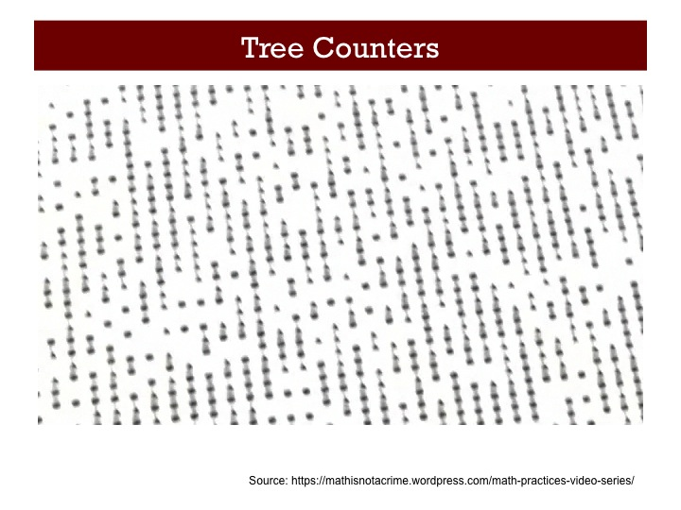
Supporting Students in the Classroom  (20 minutes starting after 70 minutes)  The practice standards are a guide to good math instruction, forming the foundation for mathematical thinking and practice in our classrooms. However, the eight practices are a lot to take in and if we are going to see our students engage with them fully, we need to make them accessible. In order to do this, students need to have a grasp of what the practices actually mean and the skills they will be exhibiting when engaging with them. | Slide 40  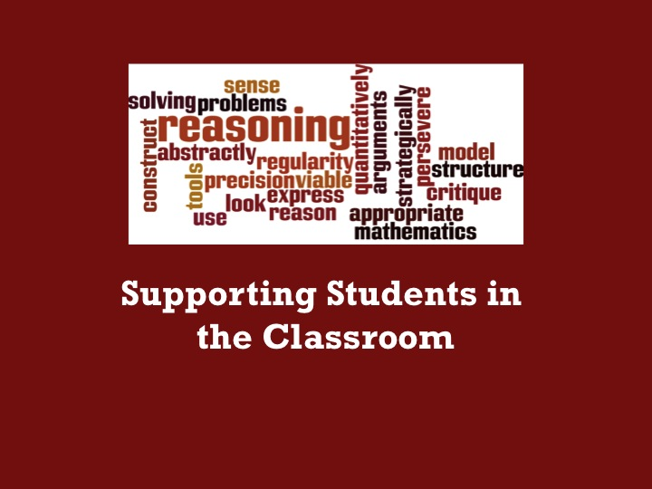
Here’s an example of expanding the mathematical practices using language that students can easily understand. It can be found on Handout 6.  Read the slide.  The table was designed for elementary students. It translates the eight practices into simple sentences, providing students with accessible behavior descriptors that can be fairly easily identified and assessed.  Providing students with statements that they can easily understand and identify with helps them to recognize the practices they are engaging in. The practices become more meaningful, as they develop an understanding of what it means to operate in each of the eight areas and foster a vocabulary for describing their strategies and mathematical thinking.  The table was adapted from ‘Teaching Children Mathematics’. | Slide 41  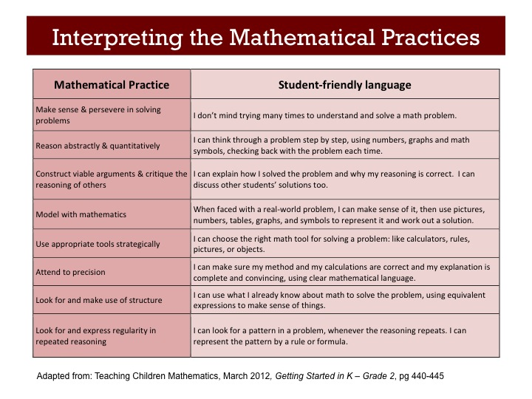
Another way in which we can support students in both understanding what the practices are and how to develop them, is to use resources in the classroom that explicitly address the processes. Jordan School District, Utah, have produced some Math Practice Charts by grade level, explaining the eight Common Core Math Practices.  This is the chart for MP1 for Grades 6 – 7. It provides the student with guidance on questions to ask before solving the problem, actions to take during the problem solving process and methods for checking and evaluating a solution once it has been completed. | Slide 42  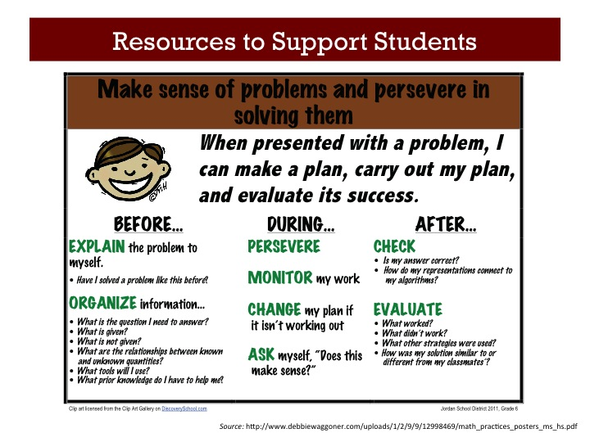
The other seven practices are set out in a similar way and can be found on Handout 7. | Slide 43  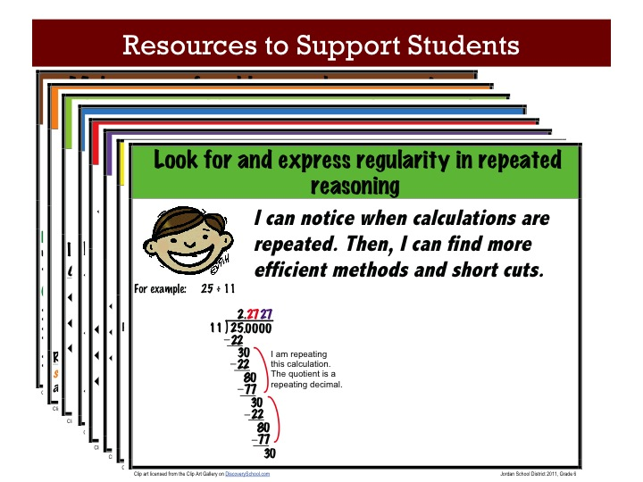
We are now going to watch a short video of a Grade 8 class reflecting on their use of the math practices. We see the math practice charts being used during the lesson, as a means of helping students to engage with the math practices.  As you watch the video, think about your responses to these three questions, which can be found on Handout 8. | Slide 44  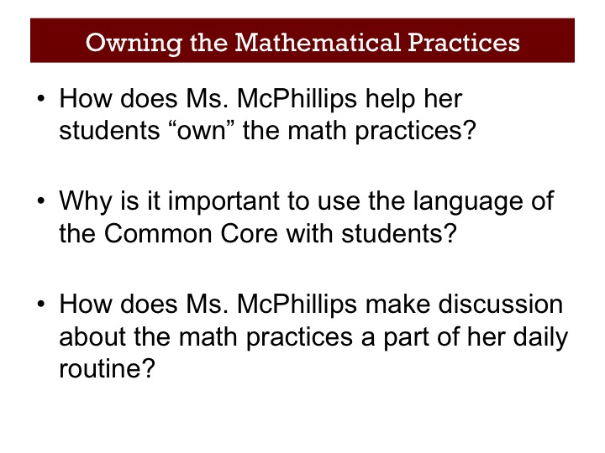
This video can be streamed from the web using the url shown: https://www.teachingchannel.org/videos/owning-the-common-core  The video lasts for just under two minutes and describes how Audra McPhillips supports her students in engaging with the eight math practices.  Let’s take a look …  Having watched the video, ask participants to share their ideas with their partner, before completing their responses on the handout. They may want to jot down some notes on the pro-forma as they watch the video. | Slide 45  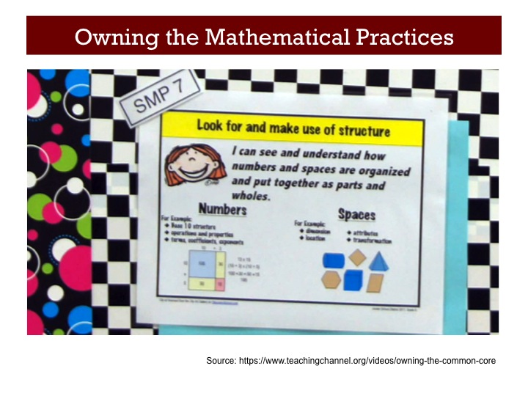
Talking about the practices with the students has become something that Audra McPhillips does everyday, in her endeavor for them to become part of students’ common language.  It is important that not only we as teachers have a clear grasp of students’ development of the mathematical practices, but that students share in this process and are able to track their proficiency at the practices, becoming familiar with the kinds of behaviors they will be exhibiting, as they develop in each of the eight areas.  In this way, as we actively monitor, as well as encourage our students to self assess their proficiency at the Mathematical Practices, it is to be hoped that we can support our students in improving and developing their mathematical expertise. | Slide 46  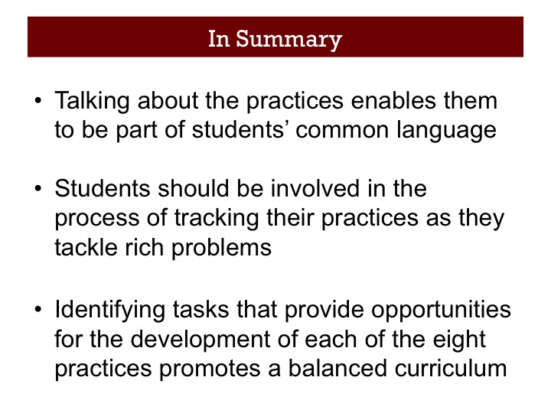

Thank you  Customize the final slide with your own contact details. | Slide 47  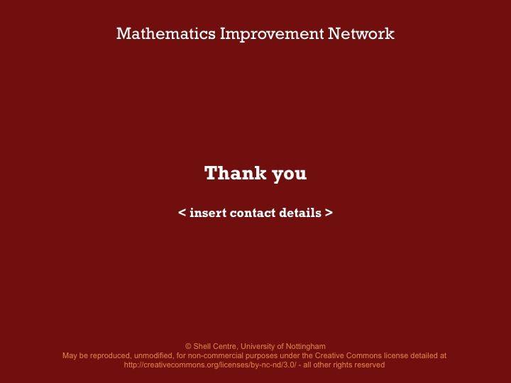

Copying
Except where noted/credited otherwise, these materials are Copyright © 2015-2017 Mathematics Assessment Resource Service, University of Nottingham. They are published under the Creative Commons Attribution-NonCommercial-ShareAlike 4.0 International license, so they may be copied and adapted for non-commercial use under certain conditions and with appropriate attribution. Please see the license for details, or contact us via http://mathnic.mathshell.org/contact.html if in doubt.
All MathNIC materials can be freely downloaded from our website http://mathnic.mathshell.org/

