Developing Mathematical Proficiency
The potential of different types of tasks for student learning

Handouts

Contents

Handout 1: The Five Strands of Mathematical Proficiency 2
Handout 2: Task A 3
Handout 3: Task B 4
Handout 4: Task C 5
Handout 5: Task D 6
Handout 6: Reflection 7

Copying
Except where noted/credited otherwise, these materials are Copyright © 2015-2017 Mathematics Assessment Resource Service, University of Nottingham. They are published under the Creative Commons Attribution-NonCommercial-ShareAlike 4.0 International license, so they may be copied and adapted for non-commercial use under certain conditions and with appropriate attribution. Please see the license for details, or contact us via http://mathnic.mathshell.org/contact.html if in doubt.
All MathNIC materials can be freely downloaded from our website http://mathnic.mathshell.org/

Handout 1: The Five Strands of Mathematical Proficiency
Conceptual Understanding | The comprehension of mathematical concepts, operations, and relations. | - Enables students to connect ideas to what they already know  - Supports retention and prevents common errors
Procedural Fluency | Skill in carrying out procedures flexibly, accurately, efficiently, and appropriately. | - Learning procedures can strengthen and develop mathematical understanding, while understanding makes it easier to learn skills
Strategic Competence | The ability to formulate, represent, and solve mathematical problems. | To come up with answer to a problem, students must:  - follow a solution method and adapt as necessary  - understand the quantities in the problem and their relationships  - represent the relationships mathematically  - have the mathematical skills required to solve the mathematical problem
Adaptive Reasoning | The capacity for logical thought, reflection, explanation, and justification. | As students reason about a problem they can:  - build their understanding  - carry out the needed computations  - apply their knowledge  - explain their reasoning to others
Productive Disposition | The habitual inclination to see mathematics as sensible, useful, and worthwhile, coupled with a belief in diligence and one’s own efficacy. | Requires frequent opportunities to:  - make sense of mathematics  - recognize the benefits of perseverance  - experience the rewards of sense making in mathematics
Adapted from: https://mathequality.wordpress.com/2012/06/25/nrcs-five-strands-of-mathematical-proficiency/

Handout 2: Task A

Percent Change Game
Use these 12 numbers to fill in the gaps below.

10, 20, 25, 35, 40, 50, 60, 70, 75, 80, 90, 100

$____ increased by ____% = $____
$____ increased by ____% = $____
$____ decreased by ____% = $____
$____ decreased by ____% = $____

You score a point for each number used only once – and in a correct expression.

Try to get the highest score you can.

(Maximum score: 12 points)

Adapted from http://www.foster77.co.uk/Percentage%20Change%20TASK%20SHEET.pdf

Handout 3: Task B

Describing and Defining a Square

Four equal sides
Diagonals meet at right angles

Four lines of symmetry
Two pairs of parallel sides

Four right angles
Rotational symmetry of order 4
Two equal diagonals

Which pairs of statements define a square? Which do not?

A lesson called ‘Describing and Defining Quadrilaterals’ based on this task, can be found on the Mathematics Assessment Project website (http://map.mathshell.org/)

Handout 4: Task C

Always, Sometimes or Never True?
Here is a collection of mathematical statements or conjectures:

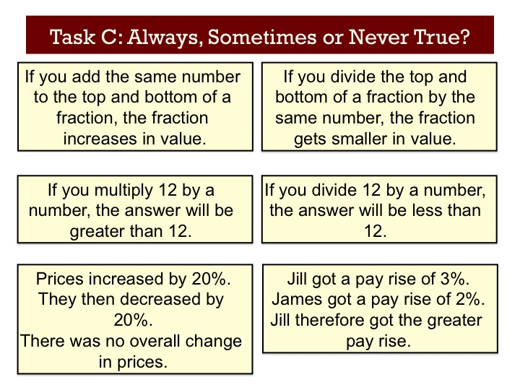

Consider each statement in turn and decide whether it is always, sometimes or never true.
- If it is always true, show some examples, and then try to provide an explanation as to why it is always true.
- If it is never true, explain why.
- If it is sometimes true, give examples and define precisely when it is true and when it is not true.

Handout 5: Task D

Schoolteachers and Dentists
There are about 320 million people in the US.

- About how many school
teachers are there?

- About how many dentists are there?

Estimate some other facts and check them out.

Adapted from http://www.bowlandmaths.org.uk/pd/pd_01.html

Handout 6: Reflection
Think about tasks that are already in use (either by you or well known tasks) and categorise them under the five strands of mathematical proficiency:

Description of Task | Conceptual Understanding | Procedural Fluency | Strategic Competence | Adaptive Reasoning | Productive Disposition

Which of the five strands of mathematical proficiency do students currently have the most opportunity to develop in your classroom?

Describe how you plan to include a balance of the mathematical proficiency strands in your curriculum over the coming weeks.

