Formative Assessment
How can it improve teaching and learning?
Leader Guide
goals
This tool provides detailed support for a 90-minute session for mathematics teachers, introducing them to the principles and practices of formative assessment.
Users
Professional development leaders with mathematics teachers.
Introduction
Research shows that formative assessment, when done well, has the power to lead to substantial gains in student learning. Many people, however, interpret the term formative assessment as meaning more frequent testing and record keeping. While such activities do have a place, assessment does not become formative unless the feedback it provides the teacher is used to adapt teaching to meet student learning needs as they are revealed, minute-by-minute in the classroom.
Both teachers and students have a role in the assessment process. The definition used in this session of formative assessment describes how:
‘Practice in a classroom is formative to the extent that evidence about student achievement is elicited, interpreted, and used by teachers, learners, or their peers, to make decisions about the next steps in instruction that are likely to be better, or better founded, than the decisions they would have taken in the absence of the evidence that was elicited’. (Black & Wiliam, 2009).
This professional development workshop is intended to allow teachers an opportunity to broaden their understanding and consider the practical implications of formative assessment. They examine five strategies of formative assessment, using tasks designed to elicit student misconceptions to give formative feedback and considering active ways in which students can engage in self and peer assessment.

Session Outline
- Assessing Students estimated times 10 minutes
- What is Formative Assessment? 10 minutes
- Five Formative Assessment Strategies: 5 minutes
  - Clarifying Learning Intentions 5 minutes
  - Eliciting Evidence of Student Learning 10 minutes
  - Giving Formative Feedback 20 minutes
  - Students as Learning Resources for One Another 10 minutes
  - Students Taking Ownership of Their Own Learning 5 minutes
- Reflections 15 minutes
Materials required
- This Users Guide, supported by a PowerPoint: ‘Formative Assessment slides.pptx’
- Session Handouts: One copy per participant (to be distributed at the start of the workshop)
- Mini-whiteboards and dry-erase markers (to be given out at the start of the workshop)
Time needed
90 minutes.
Preparation
The workshop leader(s) should carefully work through this Guide, referring to the Handouts. For the core Activity Sequence (below) it covers the same material as on the PowerPoint slides, including the notes below each slide.
Fill in your local information on the first and last slides.
Try to anticipate the common concerns that participants will have and write those issues down along with your responses to them. The ones shown below are examples taken from trials of this session.

Common concern | Suggested responses
My administrator is requiring graded ‘formative assessments’. They have to be common in all classes of the same course. | - This sounds like a confusion between ongoing record-keeping for summative purposes and formative assessment that promotes learning.  - Formative assessment doesn't involve grading; it uses task-specific feedback that improves learning. Research shows that giving stduents grades usually obstruct learning.  - What kind of feedback, other than grades, could be given and what are some ways to include students in helping with this work?
We don’t have time to do any more assessment. | - Formative assessment doesn't necessarily involve more work – it involves different work. Students can help too!  - So how can we incorporate formative assessment into instruction? What are some ways to do that?
When I find out that my students don’t know how to do something, I reteach, but then that just puts me behind in all that I have to cover. | - What do you really mean by the word ‘cover’? What is more important: what you cover or what students learn?  - Good teaching involves building solid foundations. This means building on what students already know and doing what is necessary to help them untangle their difficulties and misconceptions. It’s a slow process! Rapidly covering ground produces superficial knowledge that is quickly forgotten.
I have these results, now what? | - What are your goals? Clear goals make using formative assessment more productive. What do you want students to accomplish in the next lesson? (Note: by ‘goals’ we don't mean a checklist of items that students get right or wrong, but a statement describing the next steps they need to take in understanding and using mathematics. What will progress towards these kinds of goals look like?)
How do I have time to give productive feedback to every student? | Here are some strategies used by teachers:  - Make a list of questions to give orally, based on your students’ work.  - Write one or two questions on each student’s work, or give each student a printed version of your list of questions and highlight the questions that most fit each individual student’s needs.  - If short of time, select a few questions that will encourage the majority of students to review their work and write these on the board. Ask students to respond to your questions in writing.
How do I deal with my students’ and parents’ expectations that grades be given on everything they do? | - Be pro-active. Talk to students and correspond with parents about how you plan to give more effective feedback than grades. Explain that the tasks you set are ‘learning’ activities, and that you are trying to help students make sense of mathematics. Grades don't do this – they encourage students to compare scores, not discuss mathematical ideas.  - If you have no choice but to give scores, then hold these back and only give these much later, after students have had time to respond to written comments.
I don’t know what to look for when students are working on a task, other than right or wrong answers.  (Basically, teachers are not anticipating misconceptions or even what it looks like when students do understand). | - In planning lessons, work through the problems yourself, noting how you solved the tasks. Imagine how your students might solve them. Talk to colleagues and ask them how they would solve the problems and/or how they have seen students solve them.  - Make sure your students record how they are coming up with answers. Make sure that they know that what you require is their reasoning, not their answer, as this is what they will need for the next task.  - Work with a colleague to better understand what students are showing you in their work.

Activity Sequence
Title Slide  You may like to customize this slide and/or the last one with your own institutional and contact details. Please leave the copyright attribution, however.  Possible comments below are in plain text. Suggestions are in italics.  Users will, of course, adapt as necessary – though we recommend sticking with this activity sequence the first time or two.  Today’s workshop is about identifying strategies that we already use or could be using for formative assessment and exploring how they can impact on teaching and students’ learning. | Slide 1  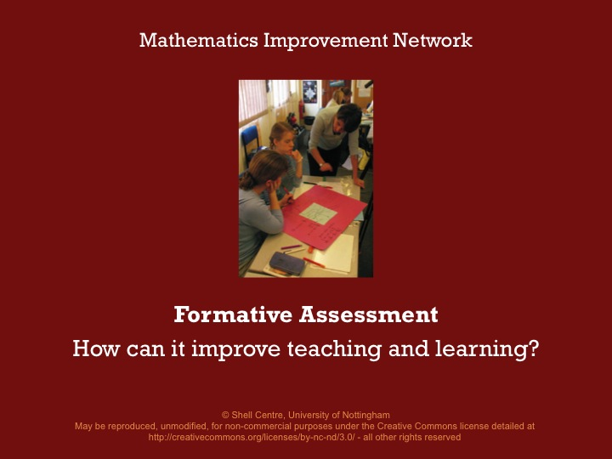
Workshop Outline  This is an outline of what we are going to work through today as we look at ways in which formative assessment can improve teaching and learning.  Rough timing  Assessing Students (10 mins)  What is Formative Assessment? (10 mins)  Five Formative Assessment Strategies: (5 mins) Clarifying Learning Intentions (5 mins)  Eliciting Evidence of Student Learning (10 mins)  Giving Formative Feedback (20 mins)  Students as Learning Resources for One Another (10 mins)  Students Taking Ownership of Their Own Learning (5 mins)  Reflections (15 mins) | Slide 2  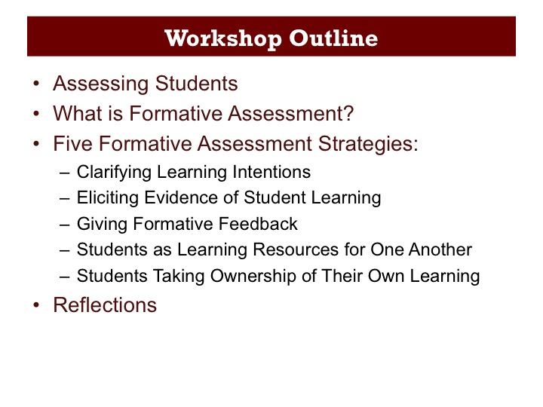
Assessing Students (10 minutes)  As teachers we assess our students using a variety of methods. We are going to start by thinking about some of the ways in which we currently assess our students. There are many ways that we assess our students, but not all of them are having an impact on our teaching and learning. | Slide 3  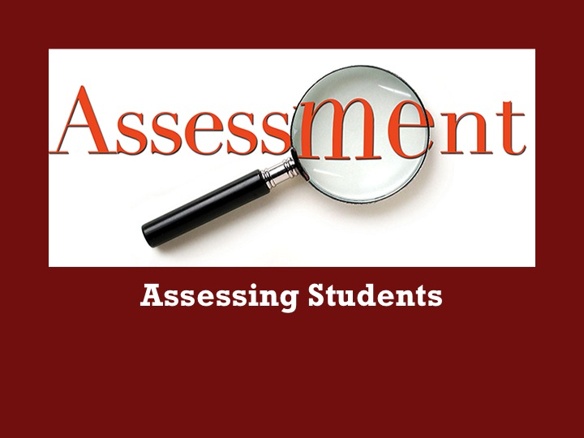
Pose the two questions on the slide and allow participants 5 minutes to discuss with their neighbor, writing down their thoughts on their mini-whiteboards.  Once participants have had a chance to share their ideas with each other, ask a couple of participants to share some assessment methods that they think do improve their teaching and students’ learning and a couple that don’t. Teachers may well have listed a range of summative and formative assessment methods. Notice how they categorize these different assessment methods based on their impact on teaching and learning. | Slide 4  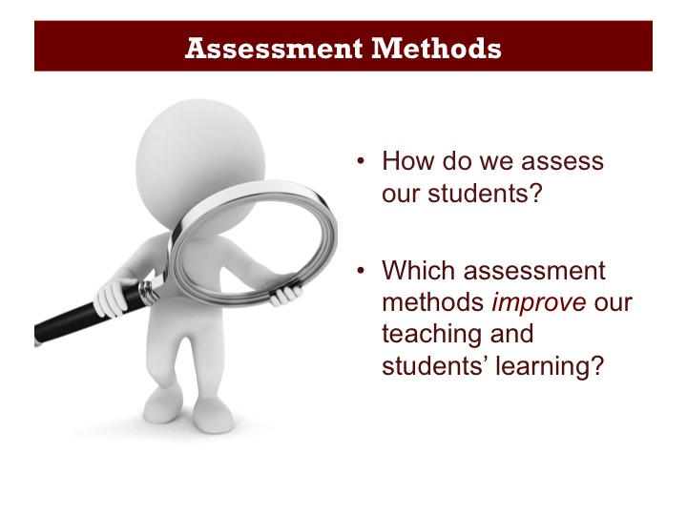
We assess our students for a number of reasons. Here are some common ones:  The first three reasons why we assess are to summarize achievement and typically occur towards the end of an instructional period. When implemented in this way, it is unlikely that they directly influence subsequent teaching and learning.  The next two reasons for assessment are embedded within a course and have the potential to influence students’ subsequent learning.  The final one is perhaps the least common, except in educational research, but it does have the intention of informing the way we teach. | Slide 5  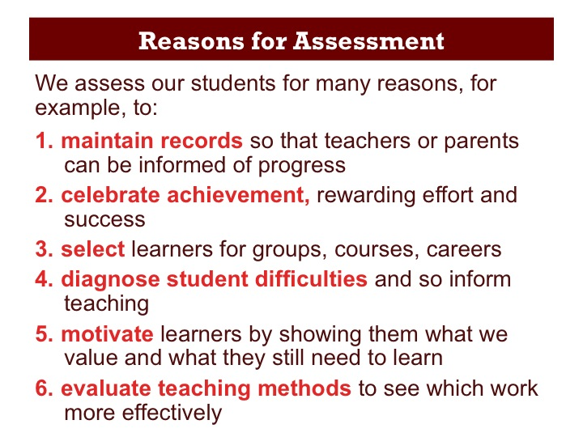
What is Formative Assessment?  (10 minutes)  So what is formative assessment and how is it different to other forms of assessment? | Slide 6  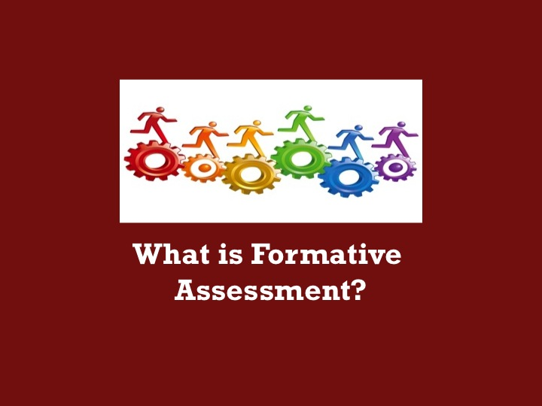
Allow a couple of minutes of individual think time before encouraging participants to discuss with their neighbor. Once participants have had a chance to share their ideas with each other, ask a participant from each table to share one idea.  When participants share what they have discussed, they may refer to tasks that involve good mathematics; thinking and reasoning, using concepts and skills and enable students to show what they can do. They may also identify such tasks as being more complex, less routine, with longer chains of reasoning, requiring more student responsibility, and autonomy. | Slide 7  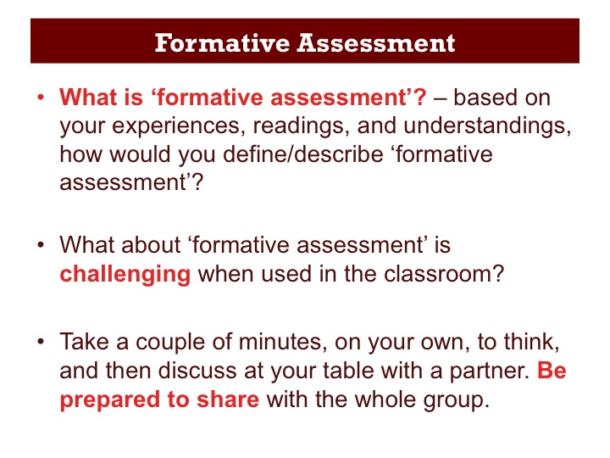
Assessment is broadly categorized into two types: summative and formative. In a balanced assessment system, both summative and formative assessments are an integral part of information gathering.  Summative assessment gauges, at a particular point in time, student learning relative to standards, but often happens too far down the learning path to provide information at classroom level to make instructional adjustments and interventions during the learning process.  Formative assessment, however, is part of the instructional process. When incorporated into classroom practice, it provides information about student understanding when timely adjustments can be made. Many teachers assume that formative assessment means testing more frequently or keeping detailed student records, making their job much harder. However, this does not need to be the case. Formative assessment practices can be embedded into our everyday work as routine. | Slide 8  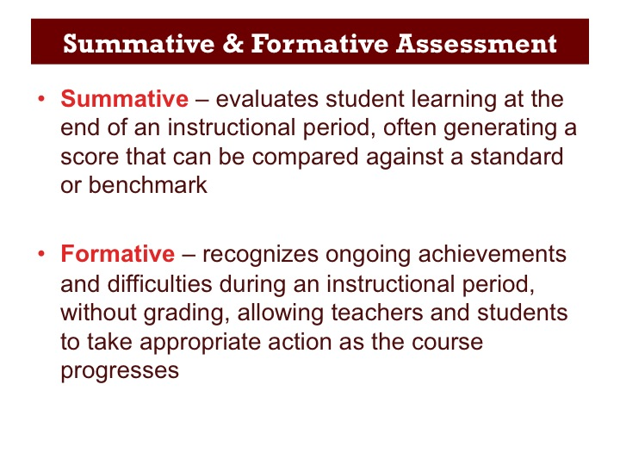
So how is formative assessment defined?  This is a definition first used by Black and Wiliam, two of the leading researchers that analyzed its potential for improving learning. Notice that it is about gathering evidence, from, for example, oral or written questioning, or from classroom observation, and then using this evidence to inform and adapt future teaching and learning. It’s not just the teachers that do the assessing; students are involved too in assessing themselves. | Slide 9  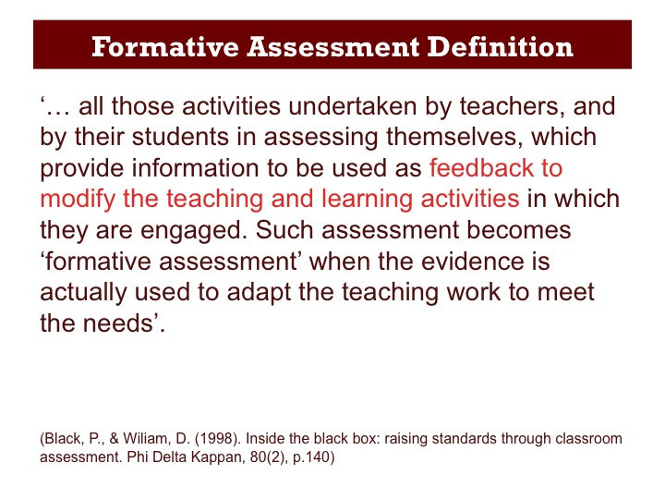
In a second definition from Black and Wiliam, which they devised later on, they make it clear that teachers, learners and peers are all involved in analysing the evidence and in deciding what to do next. If students are not involved in the assessment process, formative assessment is not practiced or implemented to its full effectiveness. | Slide 10  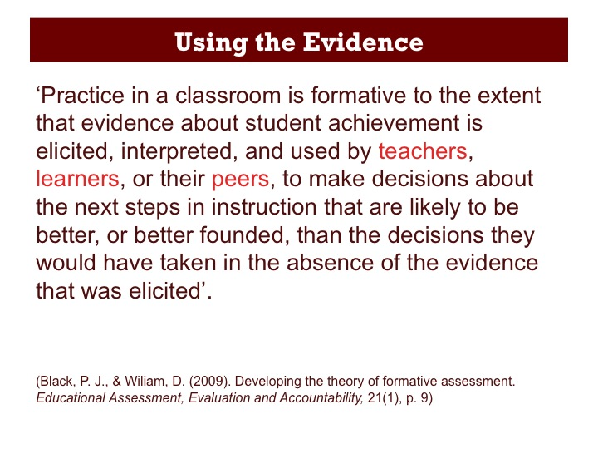
In order to carry out an assessment, we need to find out three things:  Where students are now: We need to find out what they already know and understand. This may be done by giving students a task to attempt before teaching a specific component of a unit of study.  Where students are going: To determine what we want students to learn, we must analyze our learning targets precisely, determining what it is we want students to take away from this part of the unit.  How to get there: For students to learn, we need to find practical ways to bridge the gap between where they are and where they need to be.  These three things can be applied to students’ long and short-term goals, whether they are aiming for the summit or a camp on route to the mountain peak. | Slide 11  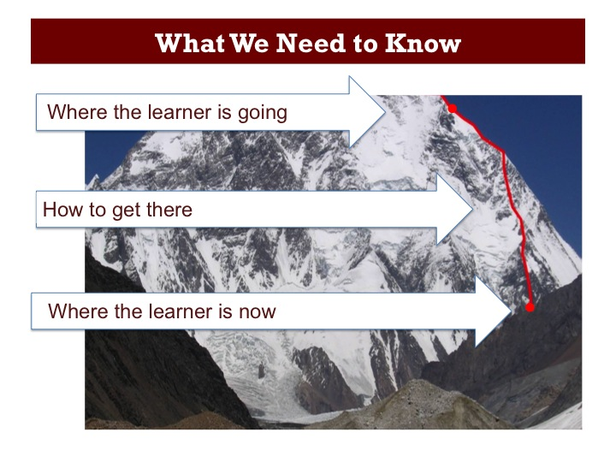
Five Formative Assessment Strategies  (5 minutes)  So let’s look at some strategies for making this happen … | Slide 12  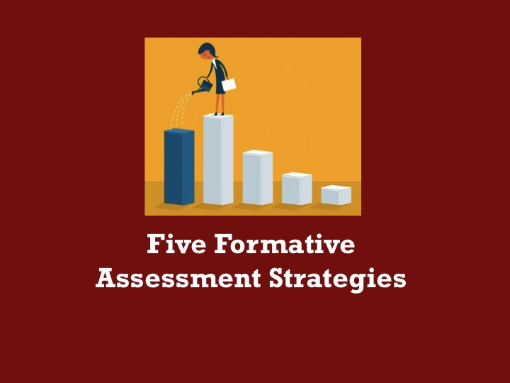
In 2007, Wiliam and Thompson, taking into consideration the roles of both the teacher and student, identified five key strategies that conceptualize formative assessment.  They proposed that the three processes of establishing where learners are, where they are going and how to get there, were central to building a framework for formative assessment.  Move straight next slide. | Slide 13  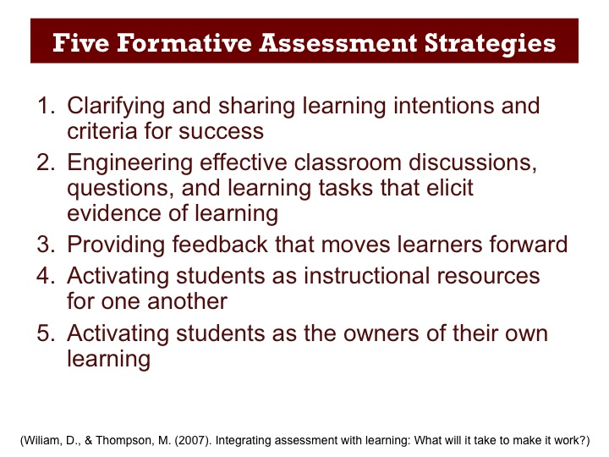
The framework provides a way of thinking about the five key formative assessment strategies with regard to the classroom participants of teacher, peer and learner. If we consider the roles these three participants play in relation to the instructional processes we see that:  1. All have a role in discussing, clarifying, and sharing the learning goals.  2. The teacher must select tasks and facilitate discussions that ensure that students’ thinking becomes visible and available for analysis.  3. The teacher must provide feedback of a type that moves student learning forward.  4. Students must work together to help one another establish shared goals and make progress towards these goals.  5. Students must take responsibility for their own learning. | Slide 14  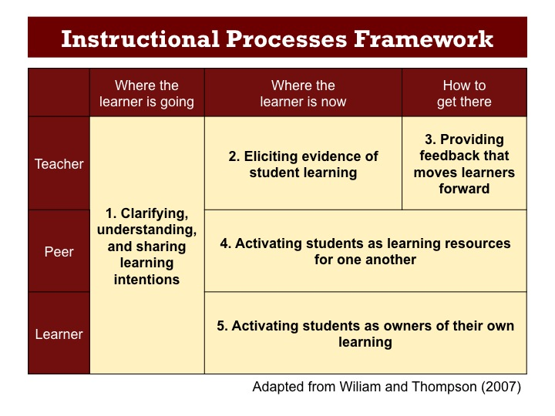
We are going to look more deeply at each of the five formative assessment strategies but first; you may be wondering how we know that these strategies actually work?  Well, there is overwhelming research evidence that shows they do work.  Black and Wiliam carried out a review of research into this and found that formative assessment, when well done, provides one of the most effective interventions that we can make to improve learning. | Slide 15  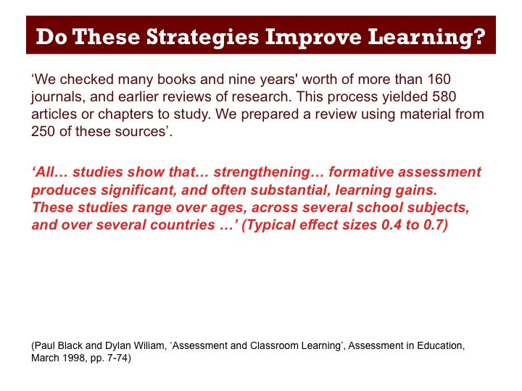
1. Clarifying Learning Intentions  (5 minutes)  So let’s start by looking at the first strategy: ‘Clarifying Learning Intentions’. | Slide 16  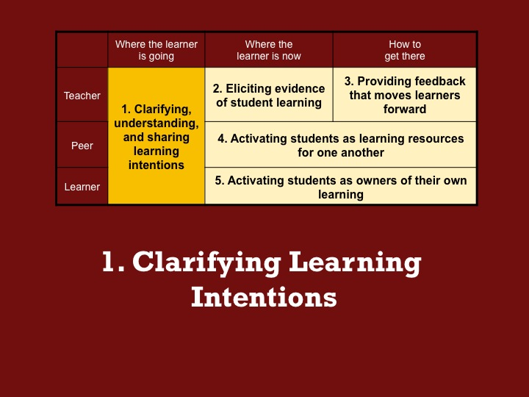
Broadly speaking there are three kinds of learning intentions in mathematics teaching:  Procedural Fluency: Carrying out procedures accurately and fluently (e.g. solving an equation).  Conceptual Understanding: Explaining a mathematical idea, concept or procedure and using it appropriately.  Problem Solving Strategies: Selecting appropriate methods when solving problems, to clearly explain and communicate reasoning.  We can often find that we focus on developing procedural fluency with our students most of the time, spending less time on developing mathematical understanding and problem solving strategies. Whatever the learning intentions, it is important that our students understand the goal and success criteria of what they are doing. There are many ways to communicate this. ‘I Can’ statements are one such way, which, if used, should be written in such a way that they can be formatively assessed throughout the lesson. An example might be ‘I Can use reasoning to solve a problem’. | Slide 17  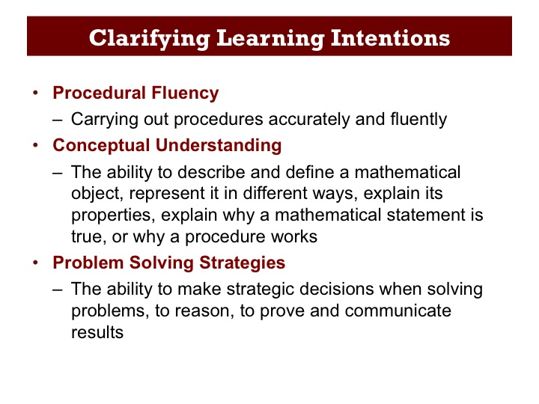
As part of the Mathematics Assessment Project, the Shell Centre designed 100 Classroom Challenges that help teachers to integrate formative assessment into everyday teaching. Two thirds of the lessons focus on assessing and developing conceptual understanding while the other third focus on the application of previously learned mathematics to solving non-routine problems.  The lessons can be found at the website address shown.  We are going to look at one of these Classroom Challenges in some detail. | Slide 18  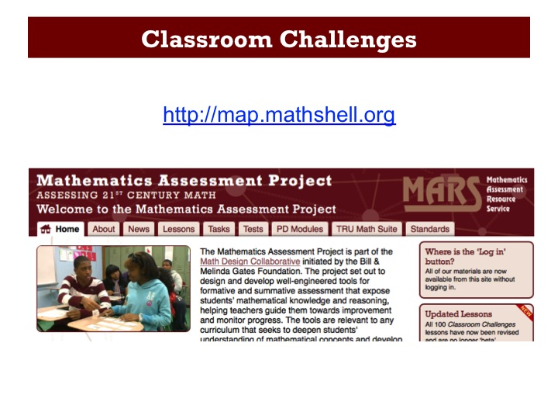
The Classroom Challenge we will look at in this session was designed for Grade 8 students and aims to find out how well students can interpret distance-time graphs, and to move their reasoning on.  The lesson contains multiple representations (graphs and written descriptions) of a number of different scenarios related to everyday events, to formatively assess students’ ability to interpret and make connections between words and graphical features.  Tables of data are added as a third representation to help students to confirm or modify their existing thinking.  Throughout the lesson, students are encouraged to articulate their reasoning and justify their choices mathematically. | Slide 19  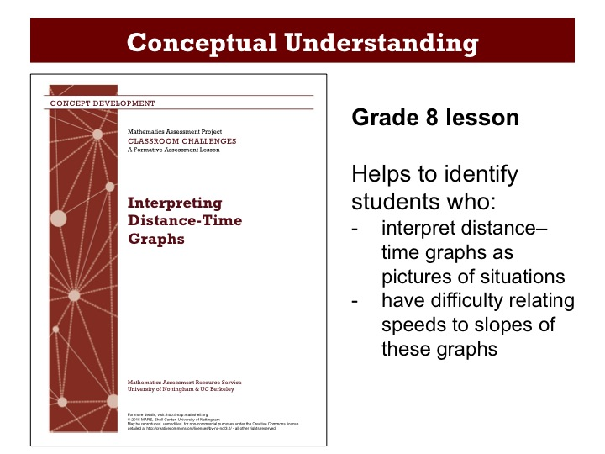
2. Eliciting Evidence of Student Learning  (10 minutes)  Once we know what it is that we want our students to learn, it is important to collect the right sort of evidence about the extent of students’ progress toward these goals.  This means that we need to use tasks, activities, and questions that will elicit the right kind of evidence of students’ learning. | Slide 20  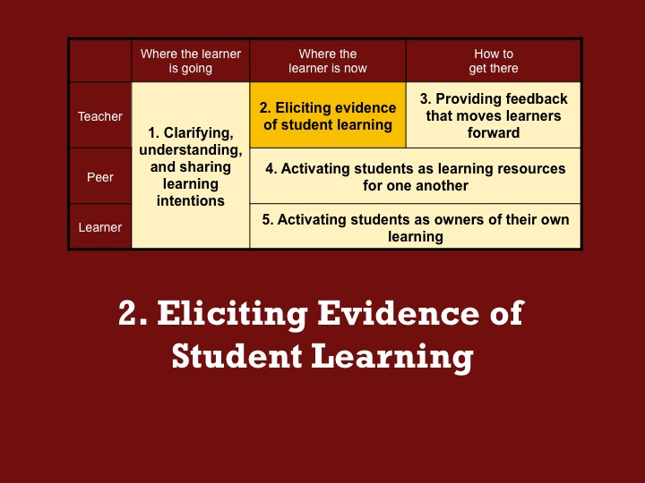
The concept-focused Classroom Challenges all follow a similar structure:  Before the lesson teachers and students get an insight into their current understanding. The teacher is able to use this information to shape the lesson that follows and the students are aware of their starting point.  During the lesson students work in groups on a task designed to encourage collaborative discussion. They compare and revise their work as they progress in their thinking.  After the lesson students reflect on their initial work and what they have learned during the lesson, to complete a task similar to that completed before the lesson.  This structure provides just one way of incorporating formative assessment strategies into lessons. While formative assessment can be implemented in other ways, an examination of the Classroom Challenge structure will provide exemplification of an approach that has proven to be successful. | Slide 21  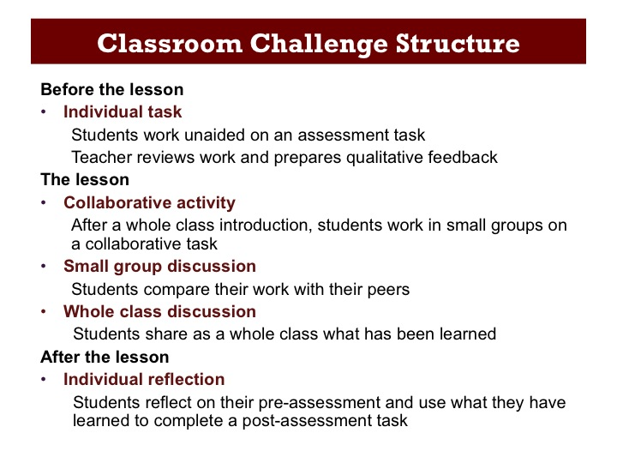
Let’s start by looking at what happens before the lesson …  In order to find out where students are at, prior to the lesson, the Classroom Challenge contains an initial task for students to complete on their own. The task is designed to support formative assessment, highlighting any misconceptions the student might have.  While there are many ways of gathering evidence, an initial assessment task designed specifically to expose student misconceptions, has proven to be an effective way of finding out where students are in their understanding. | Slide 22  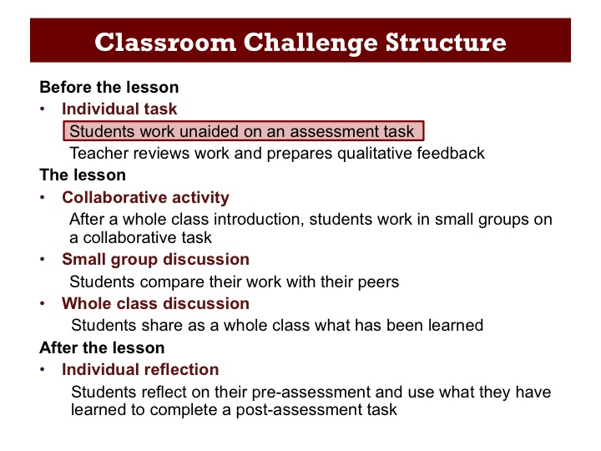
The initial assessment task included in the ‘Interpreting Distance-Time Graphs’ Classroom Challenge is set in the context of a journey to a bus stop.  The students are asked to describe the ‘story’ that may have resulted in a given graph.  Let’s have a look at the task a bit more closely … | Slide 23  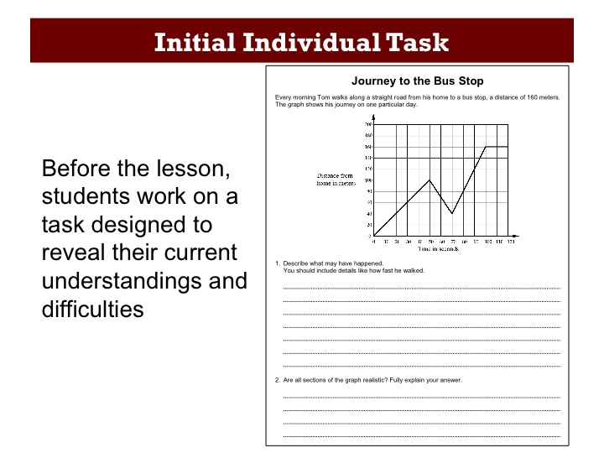
The ‘Journey to the Bus Stop’ task can be found on Handout 1.  On your own, have a go at the task.  Once you have completed both questions, discuss your answers with your neighbor and then, together, think how students might respond to the task and any difficulties they might have.  It is important that participants are given the time to work on the task prior to reviewing student responses. If there isn’t time for participants to discuss different approaches students might take, ensure that they are all familiar with the task before moving on. | Slide 24  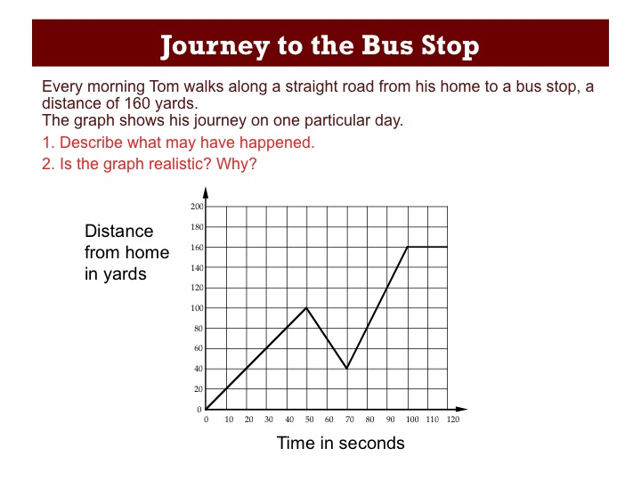
3. Giving Formative Feedback  (20 minutes)  We will now look at some actual student responses to the ‘Journey to the Bus Stop’ task and think about the kind of formative questions and prompts we could pose to the student to help to move their learning forward. | Slide 25  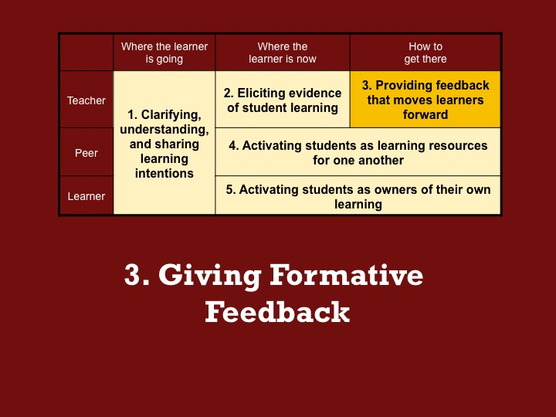
Once the students have had a go at the initial assessment task, the teacher is able to review the responses and identify students’ difficulties. The teacher then prepares qualitative feedback questions for the students and can then use the insights gained from students’ work on the pre-task to shape the lesson that follows.  The process of producing formative feedback comments is key.  We will spend the next few minutes looking at some student work on the ‘Journey to the Bus Stop’ task and think about suitable questions that we could ask to move the students’ thinking on. | Slide 26  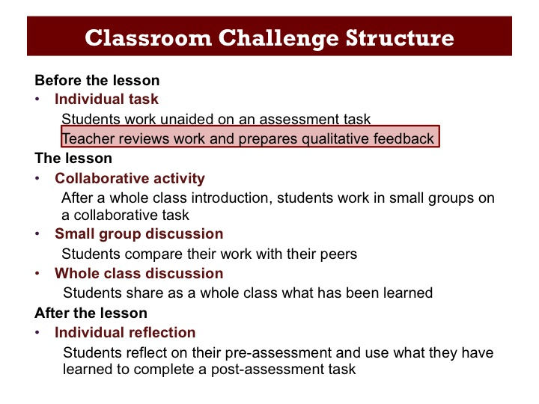
We will look at two pieces of work and respond to these two questions for each piece of work. | Slide 27  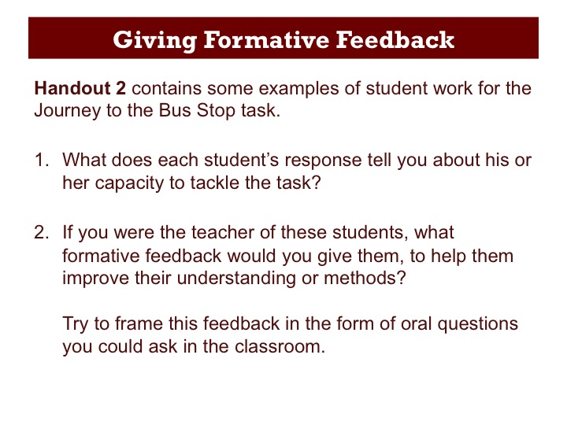
Let’s start with Alice’s response, which can be found on the first page of Handout 2.  Working on your own, try to understand and summarize how she has approached the task (Q1) (her response is transcribed at the bottom of the slide) and then write formative feedback questions that could be written on her work or posed in class to help her progress in her thinking (Q2).  Once participants have had a chance to work through Alice’s work, get some feedback from a few people and spend a couple of minutes discussing the work.  The response suggests that Alice is perhaps seeing the graph as a picture of the situation. She interprets the decline in the graph as a short cut. | Slide 28  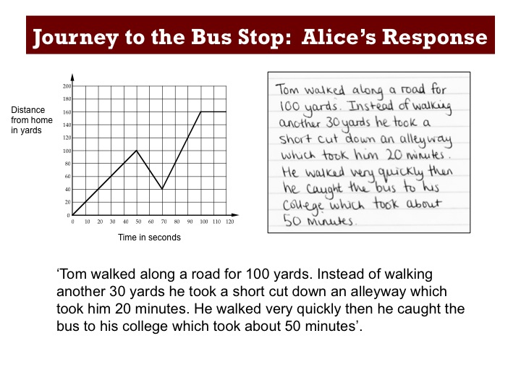
Now let’s do the same for Ben’s response on the second page of Handout 2.  Discuss the work in the same way as for Alice’s response.  Ben is seeing the graph as some kind of a speed –time graph, seeing the rises and falls as ‘speeding up and slowing down’.  By formatively assessing students’ responses to the initial assessment task in this way, we are able to come to the lesson with an understanding of ‘where students are now’.  Looking at the responses of the whole class, you are looking for common misunderstandings. For this you don't need to analyze every student's response in depth - this is not scoring. | Slide 29  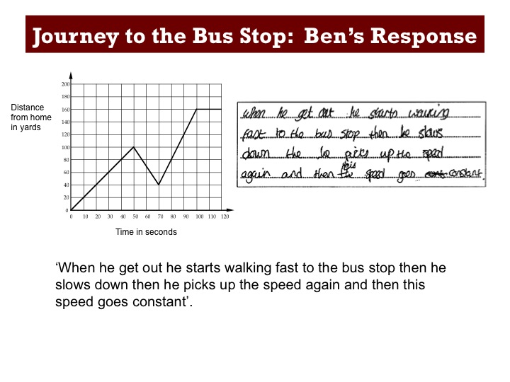
So far we have considered how we might analyze and respond to just two students’ difficulties. When you did the task yourself, there may have been other issues that you thought students might have with the task.  Here are some of the common issues and suggested feedback included in the teacher guide for this Classroom Challenge. You may have thought of others.  The authors have included common issues tables such as this for all of the Classroom Challenges. These are provided to help teachers anticipate common problems and misconceptions and prepare appropriate feedback for students. | Slide 30  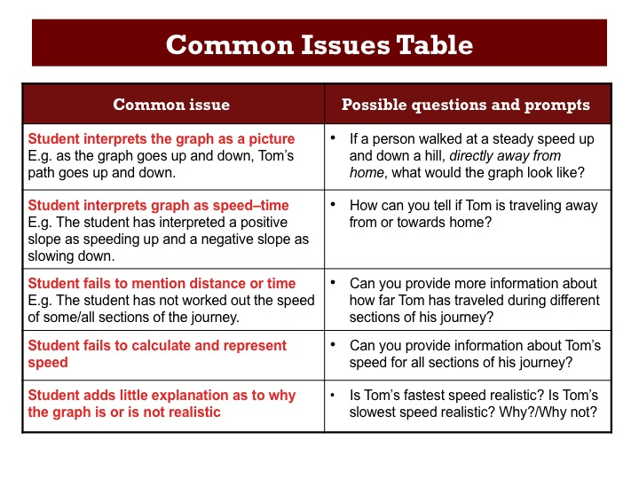
Teachers often comment that formative feedback takes too much time and students don’t really want it, they just want to know their score.  I want to show you a 2-minute video of students describing how they responded to qualitative feedback on their work for a task taken from a Classroom Challenge that focuses on problem solving strategies called ‘Counting Trees’.  You will find a copy of the task on Handout 3. Before we watch the video, spend a few minutes familiarizing yourself with the task and considering possible student approaches. | Slide 31  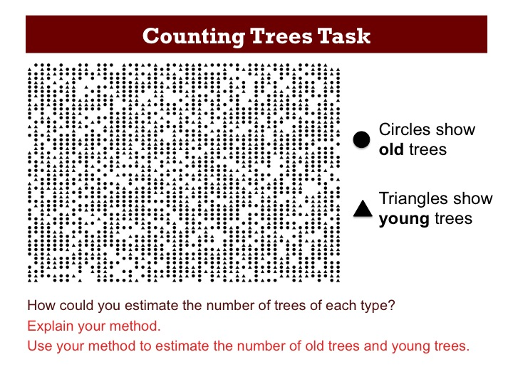
Play the 2-minute video. These students say that they ignore feedback comments when marks or scores are also written on their work. If they are just given a comment in the form of a question it makes them think and reconsider their work.  The way the students in the video describe how they respond to written feedback versus scores is supported by the research review of Black and Wiliam. Formative assessment should always be qualitative and encourage students to think again about their work. Giving scores just encourages competition among students and distracts them from the work.  Writing comments for each student takes a lot of time; often you will see common issues across the class. Then feedback questions can be listed on the board. | Slide 32  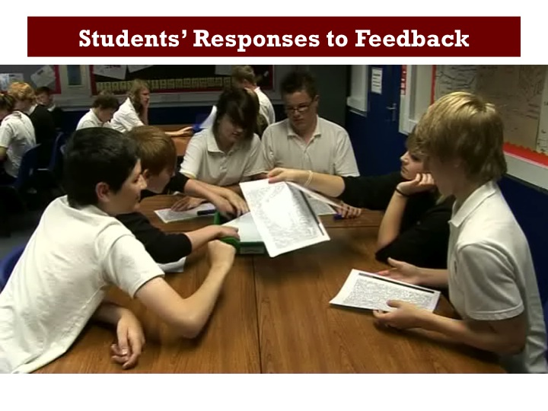
4. Students as Learning Resources for One Another (10 minutes)  For students to be activated as learning resources for each other, it is crucial that activities encourage collaboration among students while they are learning.  Let’s look at the ‘Interpreting Distance-Time Graphs’ lesson for an example of how this can be promoted in the classroom. | Slide 33  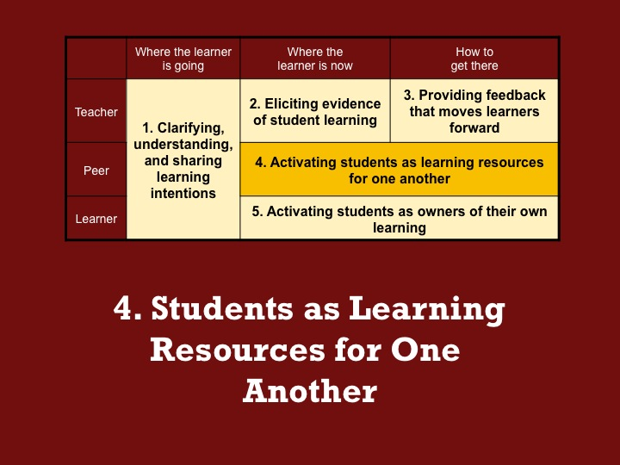
The ‘Interpreting Distance-Time Graphs’ lesson contains a 'card sort' activity that is similar in context to the assessment task.  It is designed to give students the opportunity to address their misconceptions. | Slide 34  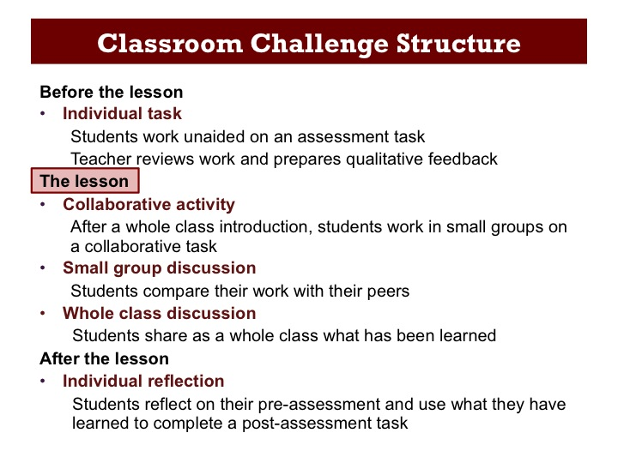
This collaborative activity is introduced by asking students to match the correct story to the graph, writing at least two reasons to support their decision.  Students who selected option A are asked to raise their hands and one or two students are invited to justify their choice. This is repeated with options B and C.  Student explanations are written next to the appropriate section of the graph, even if they are incorrect or only partially correct. Students are encouraged to challenge the interpretations given. | Slide 35  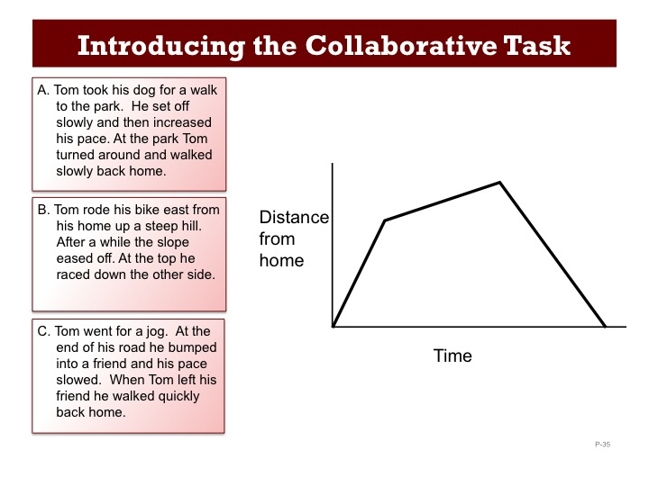
Demonstrating the process of annotating the graph to support their explanations provides students with a model of how they should work with their partners in the first collaborative activity.  Students are encouraged to articulate their reasoning, justify their choices mathematically, and question the choices put forward by others. | Slide 36  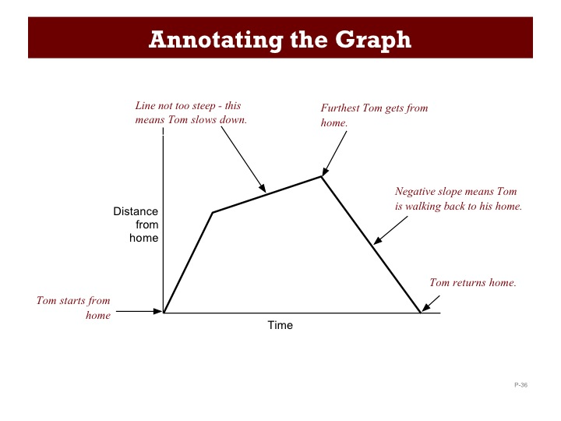
Working in small groups, students are then given ten graphs and ten descriptions to match.  (These are in Handout 4, for you to take away with you and use with your students should you wish to).  They are asked to take turns to match a pair, explaining their thinking to the rest of the group.  The purpose of this structured group work is to encourage students to engage with each other's explanations, and take responsibility for each other’s understanding. | Slide 37  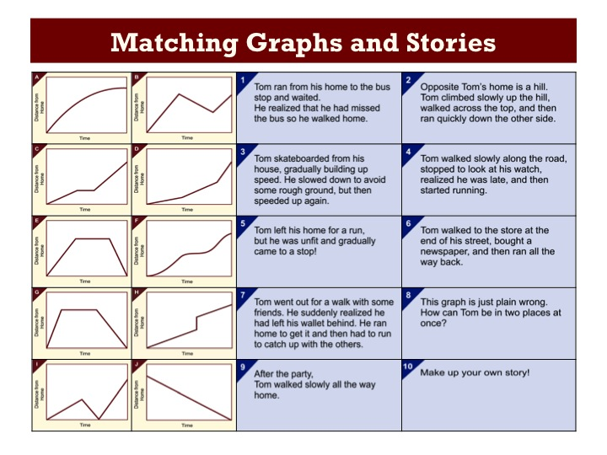
After students have matched the graphs and descriptions, they are given ten data tables to match up as well.  The tables, a different representation, provoke an alternative way of seeing things. Teachers often notice how adding the tables pushes students’ thinking and that they often see students changing matches for the graphs and descriptions because of the tables.  Both the description card set and the data table card set contain a blank card for the students to write their own story and complete a corresponding table of data. This promotes students taking ownership of their own learning, which is discussed in the next section. | Slide 38  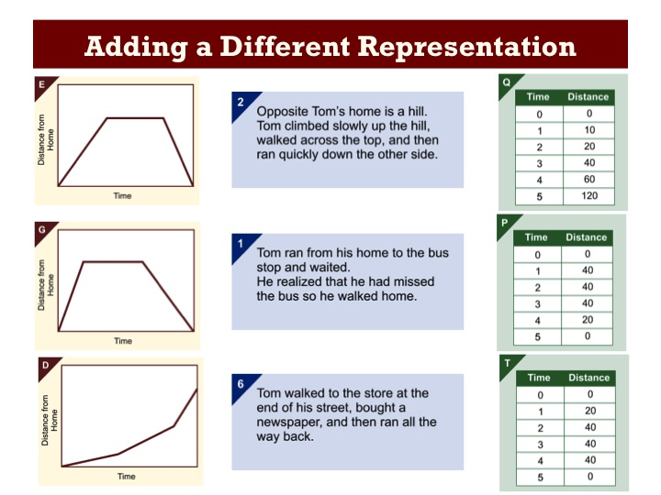
During the lesson, students have the opportunity to share their initial matches of graphs and descriptions with another group, as well as their matches of all three representations.  Students are encouraged to explain their reasoning and decide whether they want to make changes to their work, based on the explanations of others.  As they justify their thinking and identify any differences with their peers, they become resources for each other – by reflecting on their work and critiquing both their own work and the work of others. | Slide 39
5. Students Taking Ownership of Their Own Learning (5 minutes)  Let’s now consider a few ways in which students can be encouraged to reflect on their own learning and thereby take some ownership of it. | Slide 40  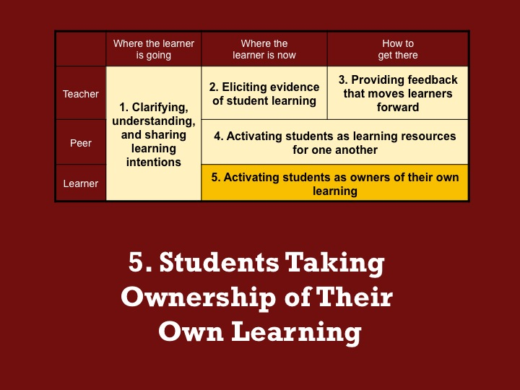
After the lesson, students receive their pre-assessment task with the written feedback and are asked to complete a second task individually, to assess what they have learned. | Slide 41  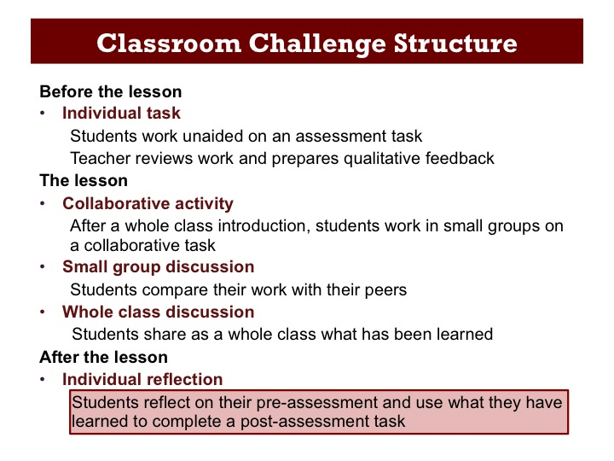

Here is the post-assessment task for the ‘Interpreting Distance-Time Graphs’ lesson.  Students gain ownership over their learning by reflecting on what they have achieved and applying their knowledge to a new, similar situation.  For some students who had considerable difficulty with the pre-assessment task, it is sometimes more appropriate for them to make another attempt at the initial task, either prior to, or instead of completing the post task. | Slide 42  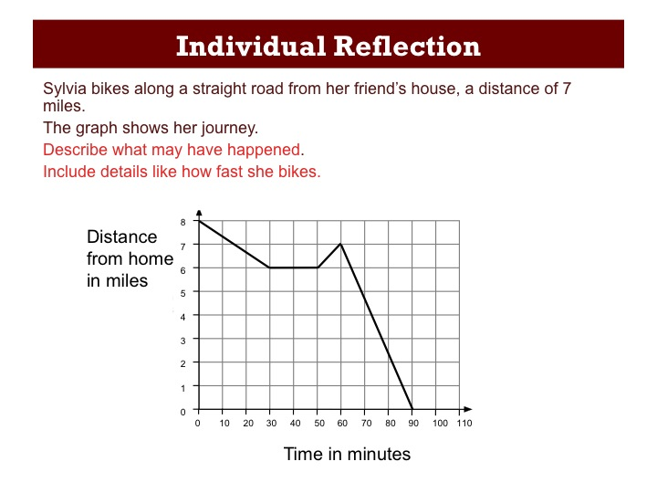
Let’s now consider some other opportunities for students to take ownership of their learning that may not be featured in this particular Classroom Challenge:  Many of the Classroom Challenges that focus on students developing problem-solving strategies include sample student work. This work addresses common misconceptions and may be incomplete. Students are given this work to assess, putting them in a teacher role, looking for evidence of understanding from a student’s response.  Other possible opportunities include students producing their own revision guide or creating a test that can be used with the rest of the class. Students can each create a question and a rubric to assess the work of their peers.  Another way for students to take ownership of their learning is for them to interview each other. It can be helpful if the teacher constructs a questionnaire template, so that the questions and responses can be recorded. | Slide 43  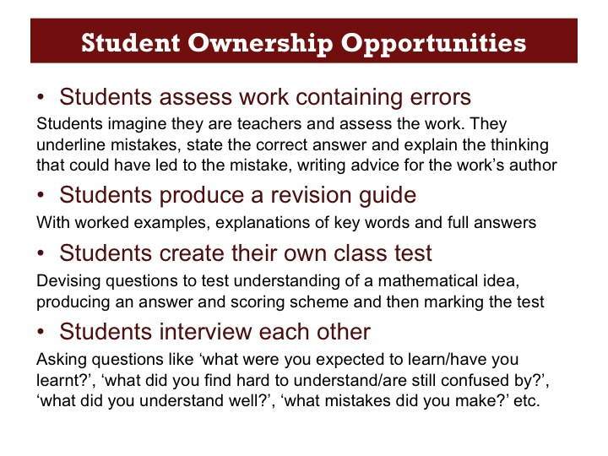
Reflections (15 minutes)  Let’s now take a few minutes to reflect on the formative assessment practices we have seen in the ‘Interpreting Distance-Time Graphs’ Classroom Challenge and how they fit into the ‘Five Formative Assessment Strategies’ we have been focusing on. | Slide 44  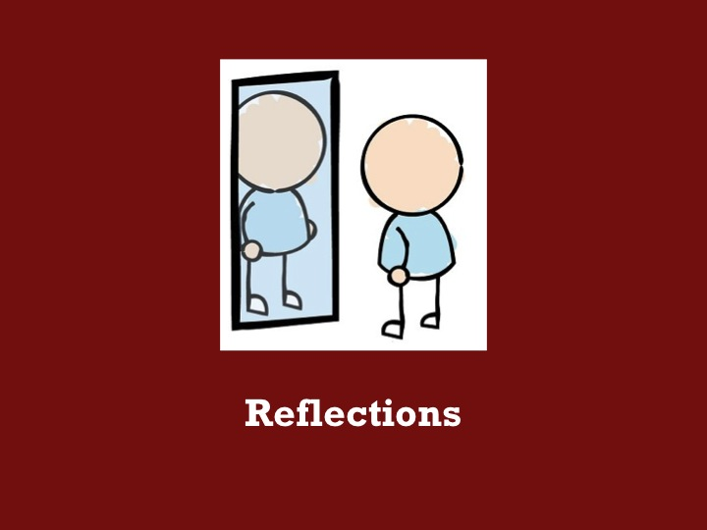
The Classroom Challenges are specifically designed to create opportunities for formative assessment. Here is a summary of the different elements of the ‘Interpreting Distance-Time Graphs’ Classroom Challenge. They are also summarized in the table on the first page of Handout 5. Together with your neighbor, categorize each of the eight activities under one or more of the five formative assessment strategies, writing the number(s) of the strategy in the right hand column of the table.  Once participants have considered the opportunities for formative assessment in the Classroom Challenge, we will extend our thinking to other common formative assessment practices. | Slide 45  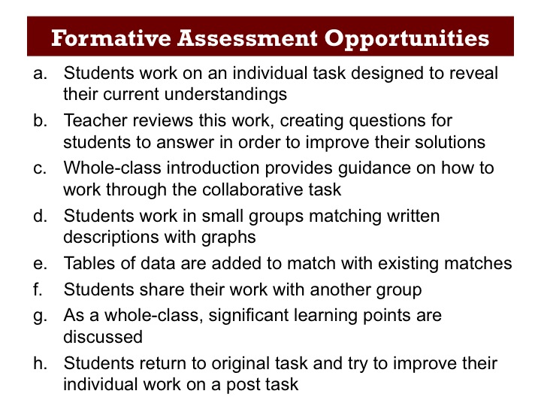
While we have considered a number of ways of using formative assessment, there are others that we could have mentioned. Let’s look at some ways of incorporating formative assessment into everyday classroom practice.  Student feedback – there are a number of ways that we can find out where students are at.  Classroom response systems – while not likely to be featured in every classroom, technology can be used to quickly collate responses from students.  Presenting work in such a way that the teacher and/or other students can easily follow it, is a useful way to aid formative assessment of students’ work.  Self and peer assessment can take many forms and has an important role to play, helping to create a learning community within the classroom. | Slide 46  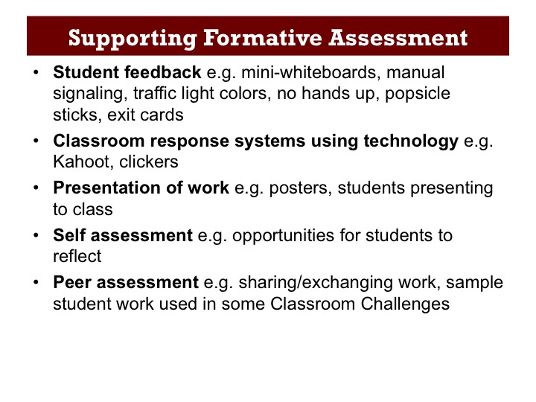
Finally, let's reflect on our own practice.  Looking again at Wiliam and Thompson’s five strategies, and thinking about all the formative assessment practices we have discussed, choose some ways that you intend to use formative assessment over the coming weeks. Working on your own, list these in the appropriate column of the table on the second page of Handout 5. There is space at the bottom of the table for any methods that address more than one of the five strategies, or that you are unsure about where to place.  Complete the handout by describing how you plan to use the formative assessment methods you have listed, with your students. The completed handout can then be used to prompt you to integrate formative assessment into everyday teaching over the coming weeks. | Slide 47  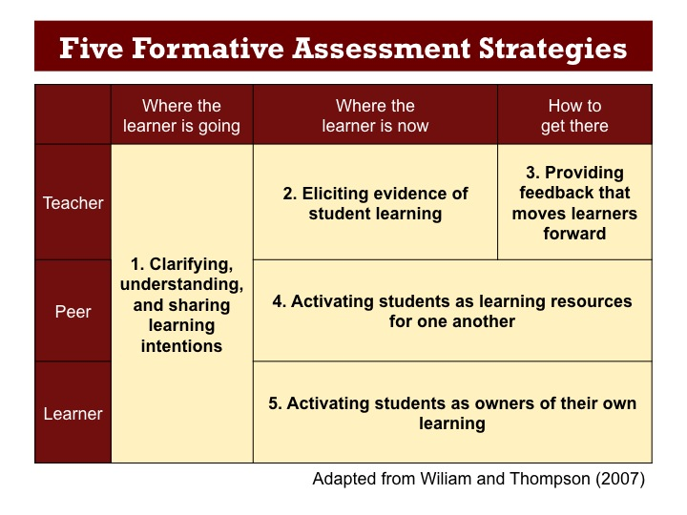
Thank you  Customize the final slide with your own contact details. | Slide 48  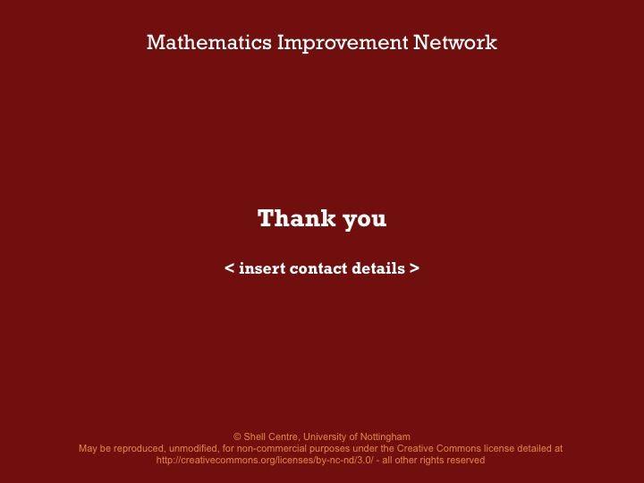

Copying
Except where noted/credited otherwise, these materials are Copyright © 2015-2017 Mathematics Assessment Resource Service, University of Nottingham. They are published under the Creative Commons Attribution-NonCommercial-ShareAlike 4.0 International license, so they may be copied and adapted for non-commercial use under certain conditions and with appropriate attribution. Please see the license for details, or contact us via http://mathnic.mathshell.org/contact.html if in doubt.
All MathNIC materials can be freely downloaded from our website http://mathnic.mathshell.org/

